# 19/10/2020

## Ideas

To do list

* Create portfolio website
* Create art for cowboy and miners character designs
* Create design for cowboy and miners gameplay
* Learn more about how to make a game in unity

Ideas

* Cowboys and miners
  + Pacman like game
    - Collect crystals
      * Gains points
    - Smash bottles over peoples heads
      * Stun opponents
    - Lock doors
      * Last 10 seconds
      * Block entry ways and trap opponents
    - Upgrade inventory
      * Collect pouches
      * +3 slots
      * Cannot put pouch inside pouch
    - Bring crystals back to mine cart
* Garden Puzzel
  + Garden fey
* Maskerade
  + Single player

# 23/10/2020

## Ideas

To do list:

* Create a presentation explaining the design for cowboy and miners game.
* Start 3d modelling the assets based on the concept designs.
* Create a website for dev diary and portfolio

I have completed concept art with designs and options for assets

TEDEMO

Ideas:

* Single button game
  + Paris bike ride
    - Press space bar to pick up and drop off customers
    - Speed increases as time goes on
    - Score increases as more customers are picked up
    - If a customer is dropped off at the wrong place game over

Brain storm:

* Civilisation management game
  + Aliens
* Endless runners
  + Jetpack jump into the atmosphere
    - Graphics small world rotating with different fields and terrain
  + Fire
    - Escape
  + Paris bike ride
    - Pick up and drop off passengers
    - Picking up passengers
      * gets points
    - Dropping off passengers and the correct location
      * gets points
    - Dropping off passengers at the wrong location
      * Loose points
    - Time runs out
      * Game over
  + Chariot race
    - Drag the mouse
    - Avoid or take out other racers
    - Collect new steeds if yours get injured
    - Try not to fall off the chariot
      * Game over
    - Try to win the race
      * Game won
* Ocean
  + Ocean exploration
  + Educational?
  + Underwater undead army(inspired by inside)
    - Puzzle, battle management
    - Play as a solider who gains sentience
    - Weird physics
    - Help your army make it to the battle and not get stuck along the way
* Weather
* Pets
  + Befriend / reject
* Crystal
  + Chemistry
  + Geology and gemmology
* Fairies
  + Puzzle
* Puzzle/platformer
  + Side scroller
  + Child characters
    - Explores the effect of childhood events/trauma
    - Ideas:
      * Strict parents
      * Outsider
      * Experiencing loss
      * Bullying
    - Gameplay effects mental stability
* Gardening/ garden management game
  + Weather system
  + No to grow in real time
* Defend
  + Defend your castle
  + Fire at enemies
  + As you progress you cannons improve
  + A medival castle shmup
* Trees
  + Tree houses
    - Build
  + Grow orchard
* Tiny
* Box
* Snow globe
* Geography
  + Erosion
* Sea birds
  + Similar to neko atsume
  + Decorate beach
  + Collect and learn about different birds
* Mandalas
* Save file mystery
  + Solve a mystery by traveling between save files
* Abseiling
* Interpretation
* Single interaction mechanics
  + Mouse movement
    - Whole screen useable
    - Time spent on surface
  + Button press
    - Hold down button
    - Number of presses
  + Game ideas:
    - One button
      * Press the button to start
      * More buttons appear
        + What so many buttons I thought there would only one
        + Hold down the button

Cycles through options

Speed up longer it is held

Button selected when let go.

# 24/10/2020

## TDEMO

For the one button game I decided to create the Paris bike ride game, driver will automatically travel through the route and the player uses the space bar to pick up and drop off tourists around Paris.

The player earns points by picking up tourists and can earn tips from dropping them off at the correct location.

The player will lose points if they drop off the tourist not in a designated location.

The player will lose points if they separate a couple of tourists

Tourists wait at designated pick up spots as either singles or couples

The bike only has room for 2 passengers you may pick up 2 singles and if you have a passenger already and attempt to pick up a couple you will separate the couple.

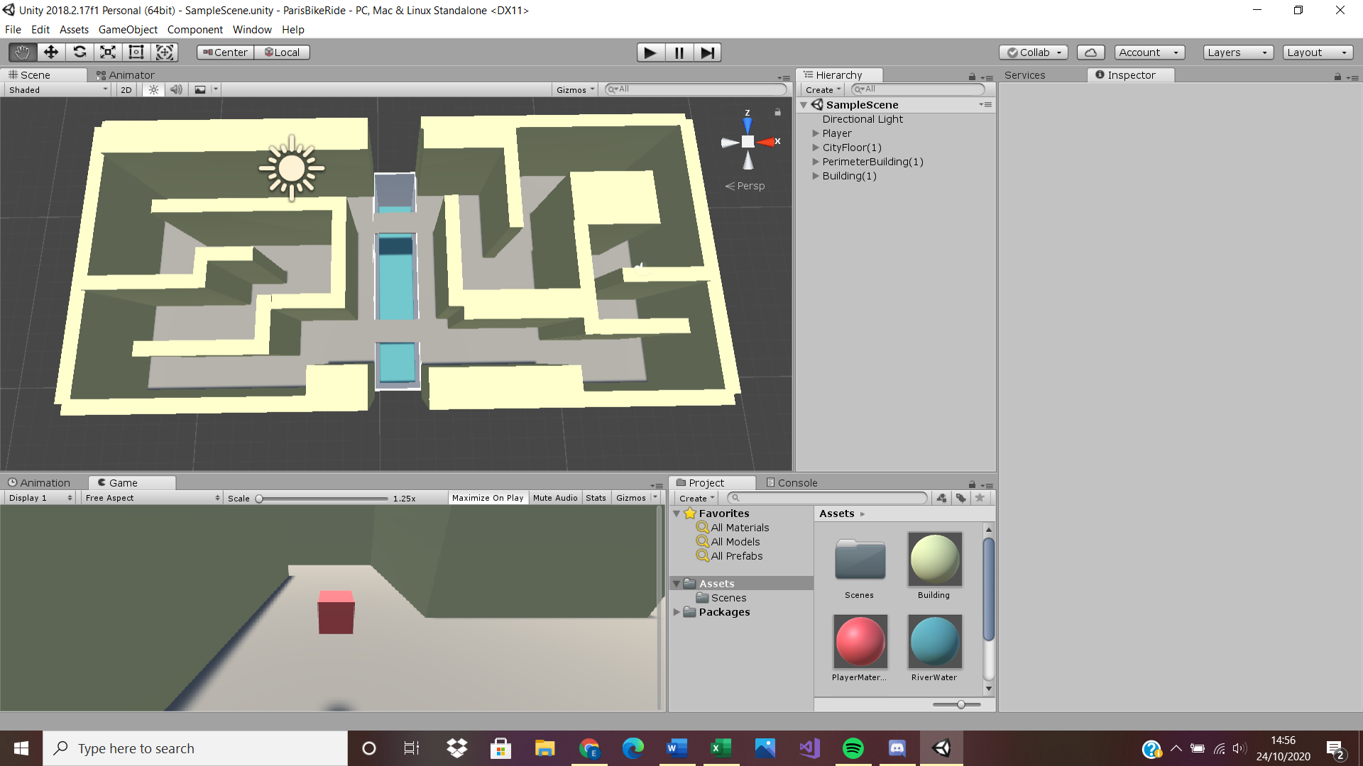

# 26/10/2020

## TDEMO

Today I am attempting to make the player object follow a set path around the map. This is the code I created following a video created by ‘Kinan gh’ on you tube.

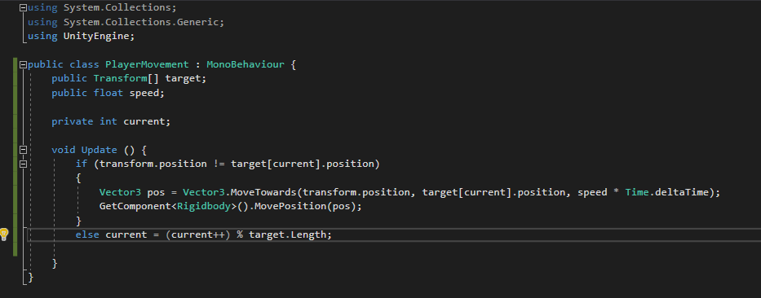

I then place targets in all the areas where the player must turn a corner

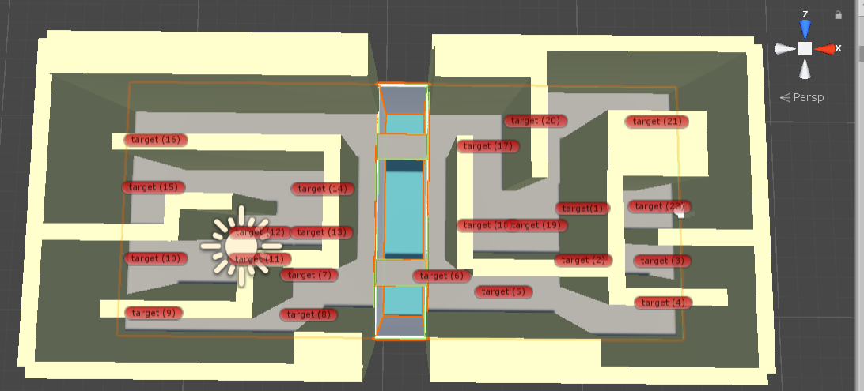

I tested this and the player moved however upon reaching the first target it falls through the floor.

I replaced the plain object for the floor with a scaled up cube which stopped the player falling through the floor however the player still gets stuck at the first target.

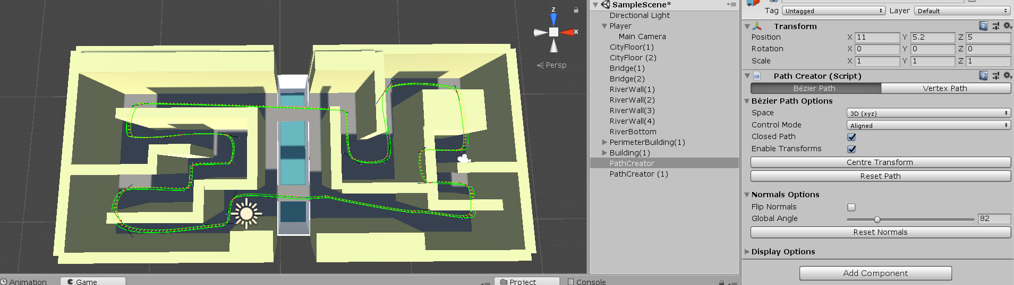

I later found a path creator free to download off the asset store which does exactly what I was trying to achieve so I downloaded this from ‘Sebastian Lague’. This allowed the player object to move around the map however the camera would face the wrong directions when it turns a corner.

Im not sure what is causing the camera to do this but it ends up facing into the centre of the loop I will try rotating the camera in relation to the player to see if this effects the issue.

# 27/10/2020

## TDEMO

I started today by adding in the place holders for the pick up and drop off points for the tourists using a green cube.

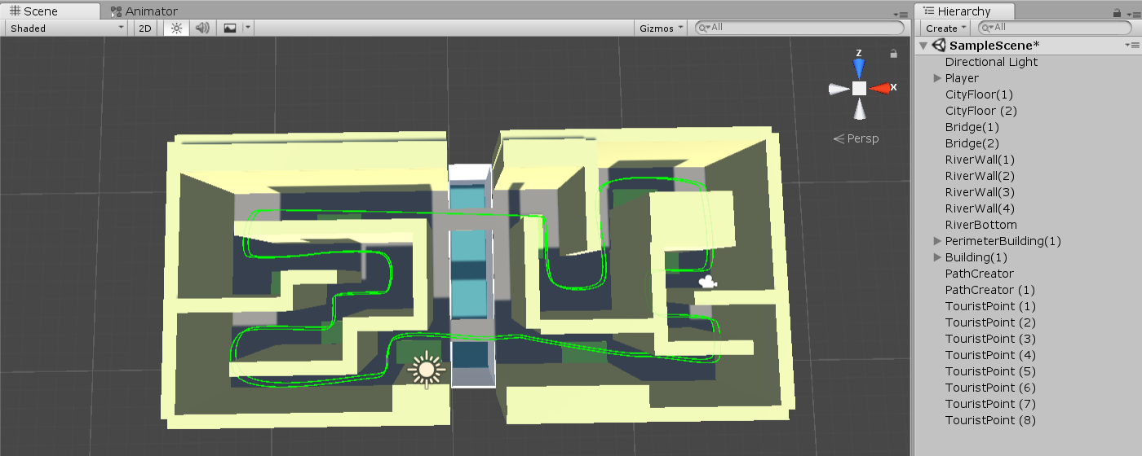

I edited some of the settings on the camera and by changing the rotation in relation to the player I found it faced the correct way while traveling round the path.

Left to do:

* Place tourists
* Code tourist generator
* Code score system
  + Increase score
    - Pick up tourists
    - Drop off tourist at a Tourist point
  + Decreese score
    - Separates a couple
    - Drop off tourist not in a tourists point
* Code pickup()
* Code dropOff()
* Code getScore()
* Code timer
* Code max amount of passangers
* Create main menu
* 3d model player
* Animate player
* Animate tourists

I created the game manager to keep track of the score

I added a box collider to the Tourist point which checks if the player is in the correct position and if they have pressed space bar if so then the score in the game manager will increase.

# 28/10/2020

## TDEMO

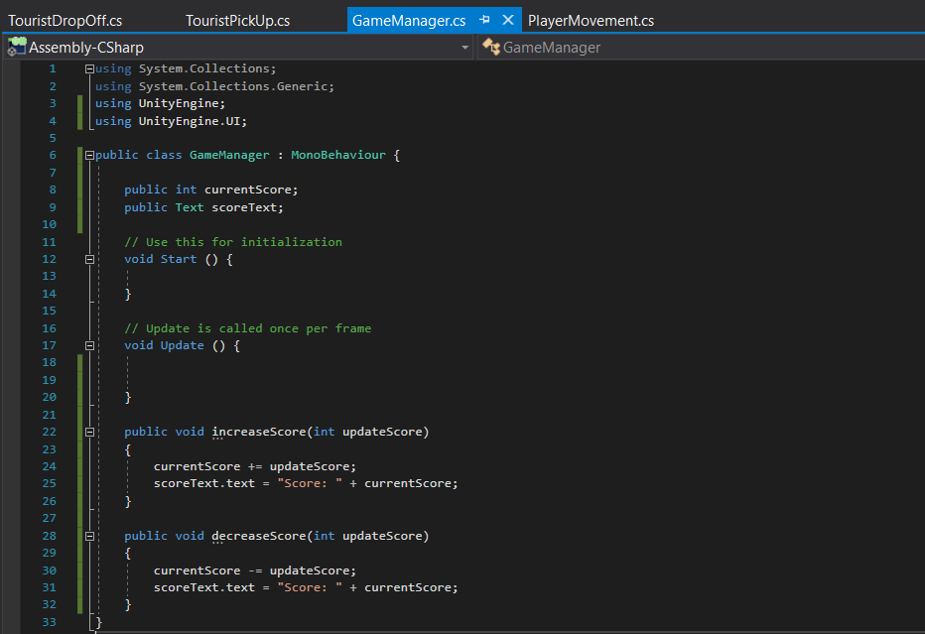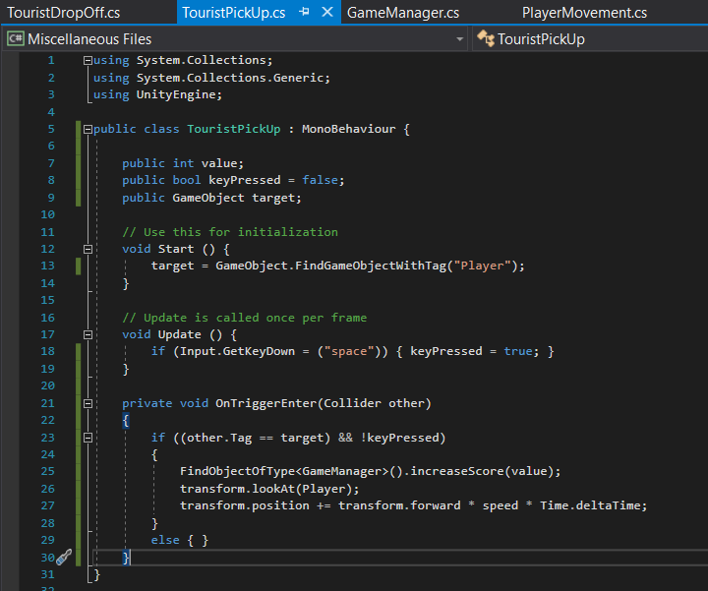

I coded the game manager and Tourist pick up function, and the score now is displayed on screen, however I have run into some errors.

Things to finish today:

* Pick up increases score
* Pick up causes tourist to follow player
* New tourist spawns when one is picked up
* Drop off checks weather score increases or decreases
* Drop off effects the score
* Drop off causes tourist to stop following the player
* Timer causes the game to end when it reaches 0

When the player picks up the tourist then they are added to the front of the queue and if the player hits the space bar again then the tourist is popped from the queue.

Ideas:

* 2DTourGuide
  + A 2D side scrolling game
  + You are a tour guide taking tourists around museums cities from all over the world
  + Get people interested by walking close to them while giving the tour and see how many people you can get to follow you

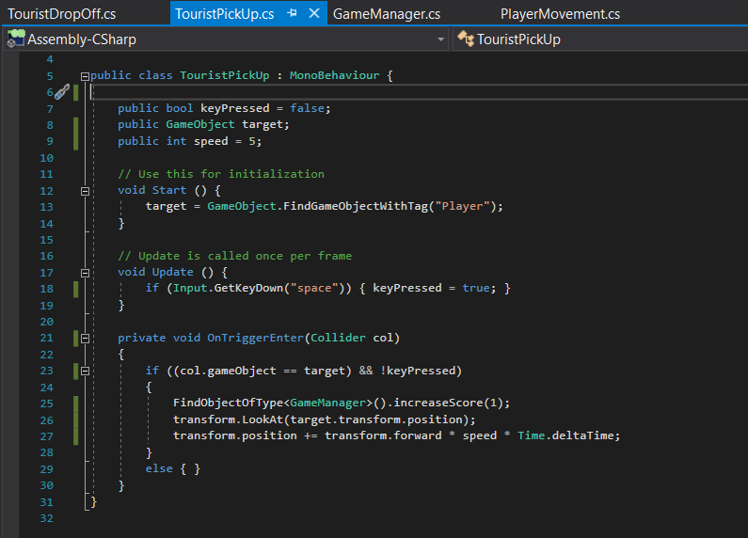

After going through the errors, I managed to get the code to run however it does not create the desired outcome. The code is supposed to cause the tourist object to follow the player however when space bar is pressed while entering the collider nothing changes.

To fix errors with the colliders I found I needed to add the rigidbody component. Now the compiler is not returning any errors however the score does not increase on the screen

I created the timer to count down to the end of the game as well and found the test displayed on the screen also did not change.

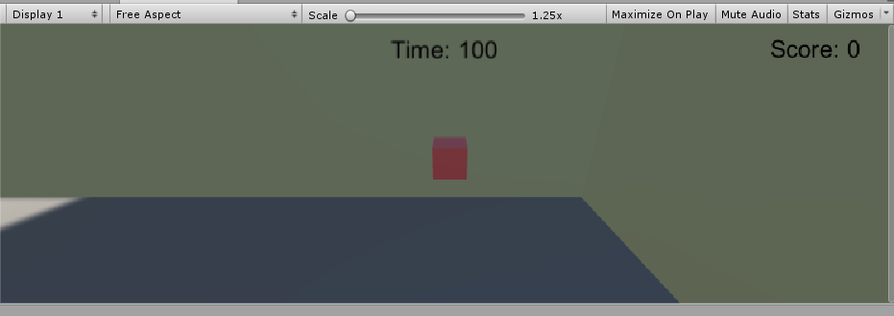

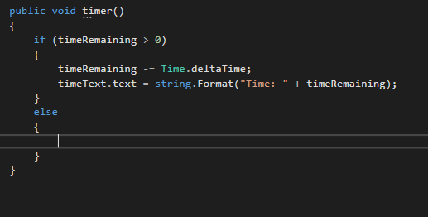

I next attempted to code the tourist following the player and leaving the touristPoint. I wished to do this by changing the parent for the tourist is a child to the touristPoint parent keeping it in place and when they player presses space the tourist should follow them so I would make the player its new parent. Then when the player presses the space button for the 2nd time then the tourist leaves the player checks for a tourist point to be dropped off at calculates the score and the trouist then has no parent and the object should be destroyed.

This code was where I started trying to change the parent class and have the object follow the new parent.

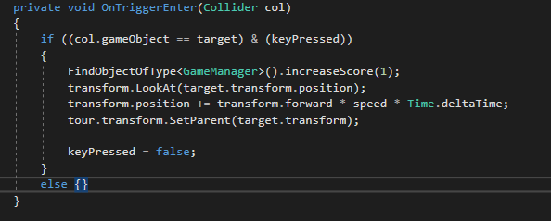

I found this code cause the tourist to follow the player at the perfect distance

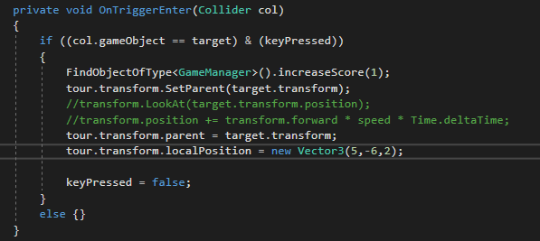

I moved onto creating the timer and used this code to create

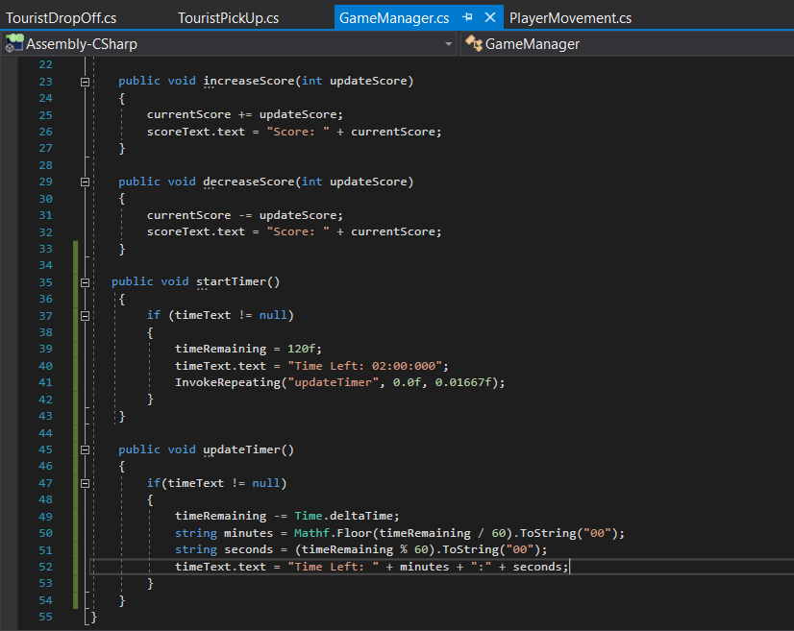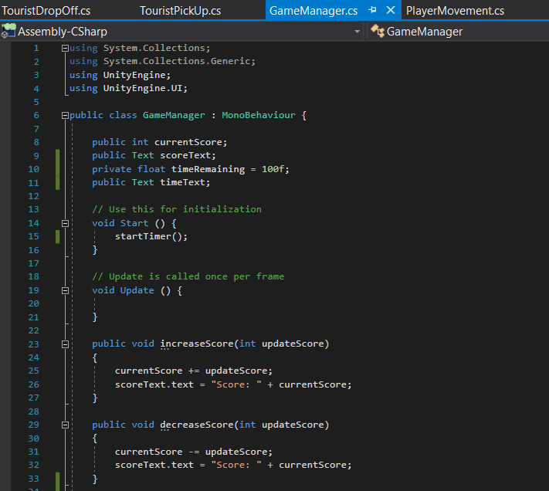

Next I need to code the times up and start screen

The start screen will display the previous score and timer set to 2 minutes and will say use the space bar to pick up tourist blocks. When the user presses space bar the game will start, the player will start moving and the clock will count down.

This is the screen I created

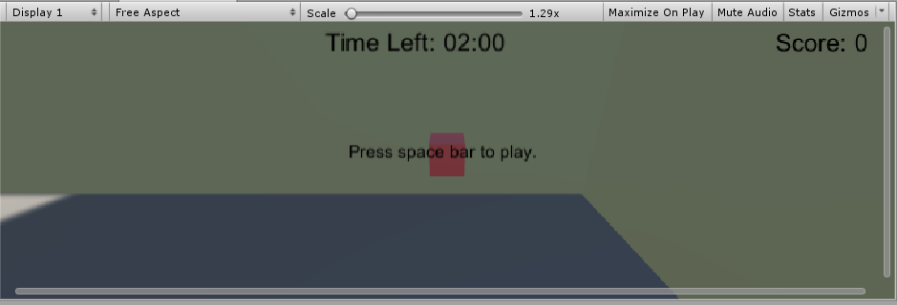

However I found even when the space bar is pressed and is registered by the engine the game doesn’t start.

This is the start function in the game manager

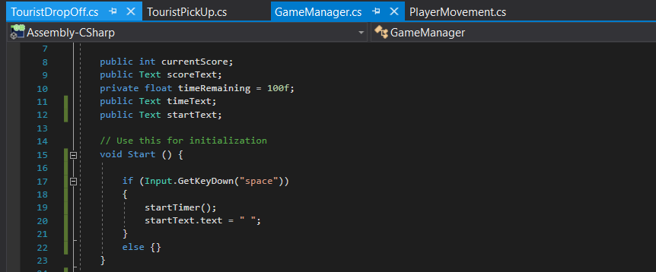

And this is the start function in the player movement

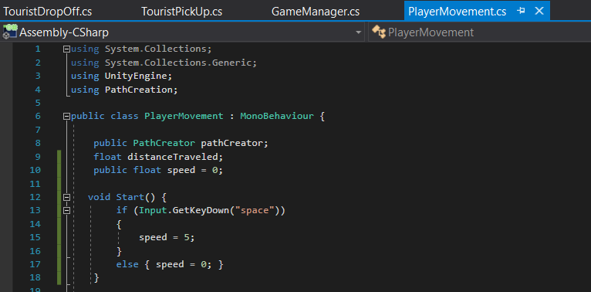

When the space bar is pressed the start text should disappear and the player should start moving around the map however neither of these events occur.

I found to get the game to start I had to move the function which started the game into the update functions. This now means the game starts correctly when the space bar is pushed. However due to the start up process happening when the space bar is pressed it causes the timer to be reset and never reaching 0.

To fix this I will have the start up process check the game isn’t currently in play before resetting the timer and score.

This is the final update code for the game manager

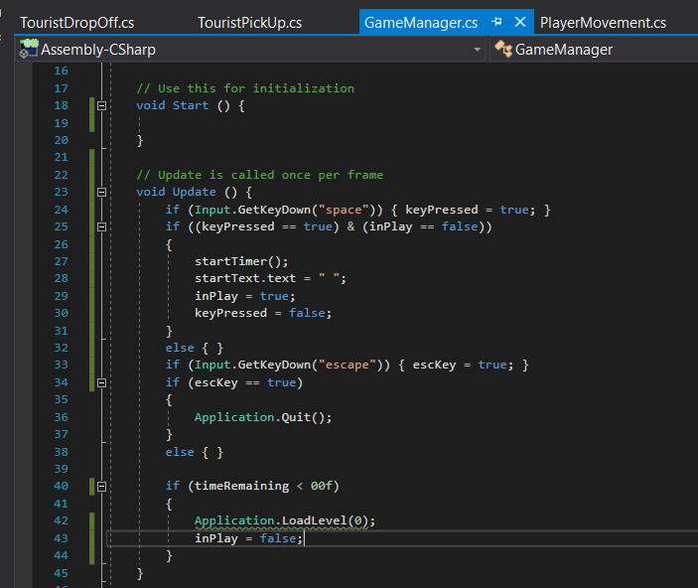

And this is the final code for the player movement

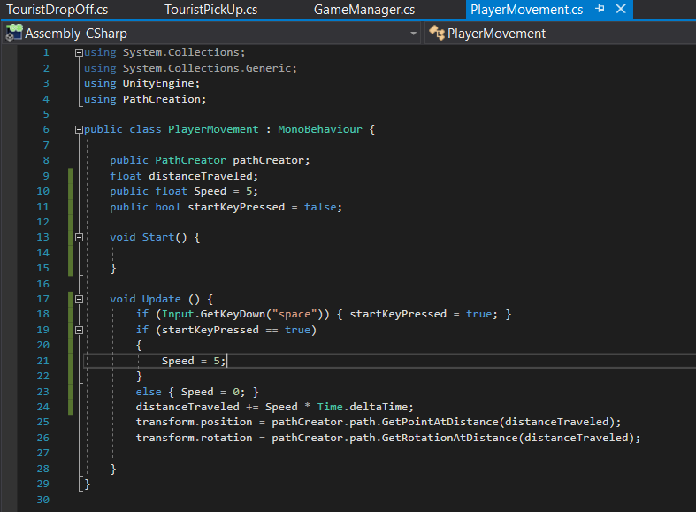

# 30/10/2020

## TDEMO

Feed back from the game jam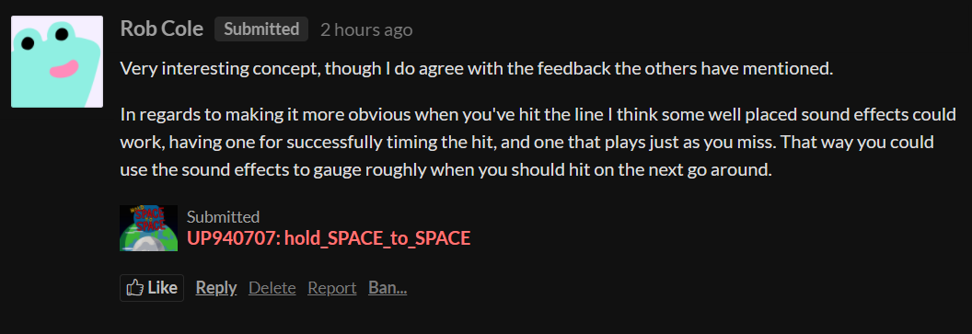

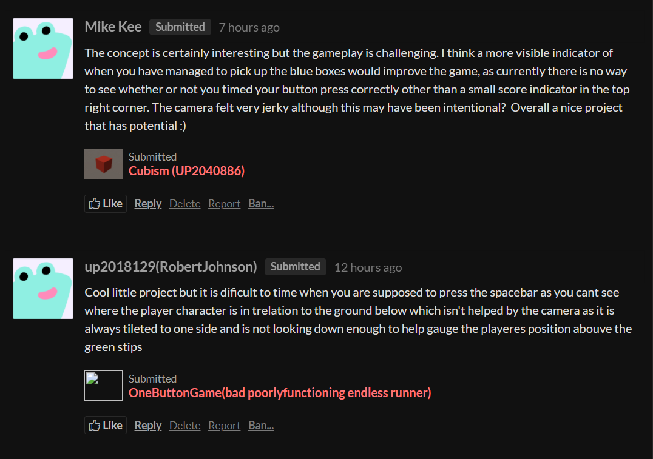

I agree with the feed back and feel like the gameplay could be improved by:

* Improving the camera angle
* And visual and sound queues when the space bar is pressed to indicate when points are scored
* Have the player move across the floor instead of floating.
* (Maybe)make the box collider on the tourist point visible to make it clear to the player

# 31/10/2020

## TDEMO

I started drawing assets for our clicker game in TDEMO.

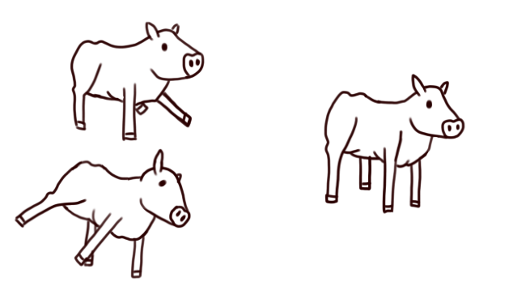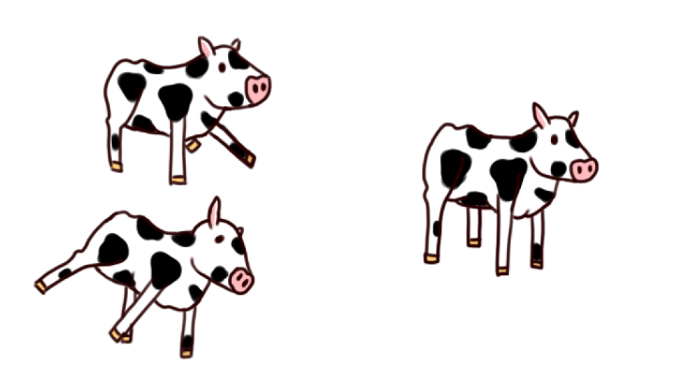

# 01/11/2020

## TDEMO

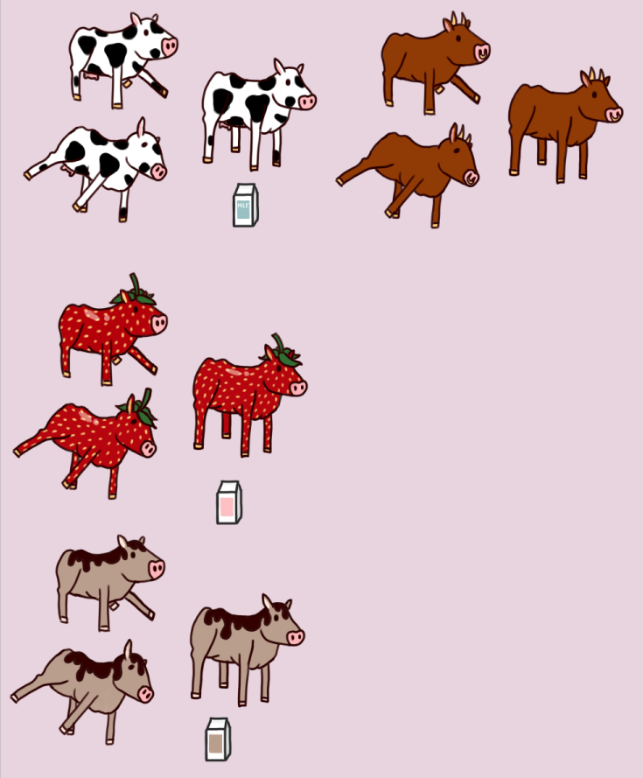

# 02/11/2020

## Ideas

* Text adventure games for TOGA
  + Shop(manage a shop)
    - Themes
      * Pet shop
      * supermarket
    - Start the day
    - Completing different tasks increases the score
    - Call functions for different events
  + Fishing boat
    - Randomly generated weather events
    - Mange money
    - Analyse conditions make decisions.

## EPORT

I have been working on making a portfolio website using wix. This is the home page where my portfolio is displayed:

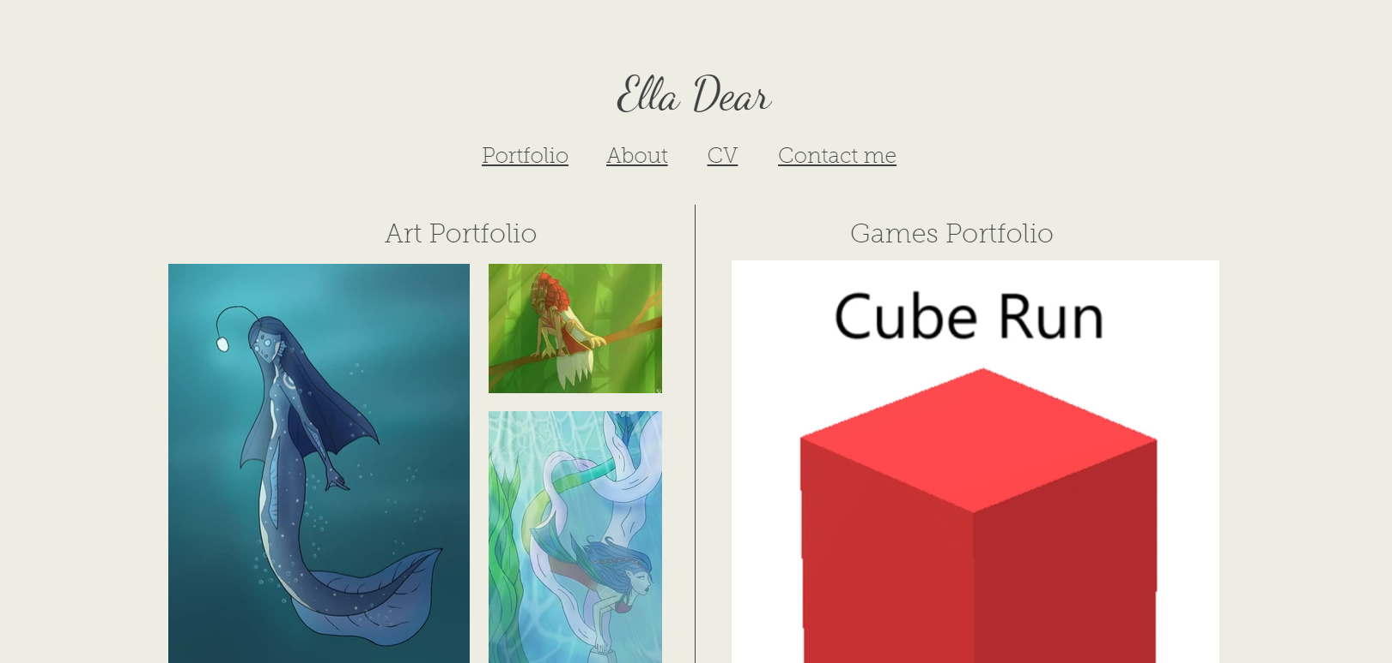

This is the about me page where I am planning or writing more to describe myself and what I specialise in.

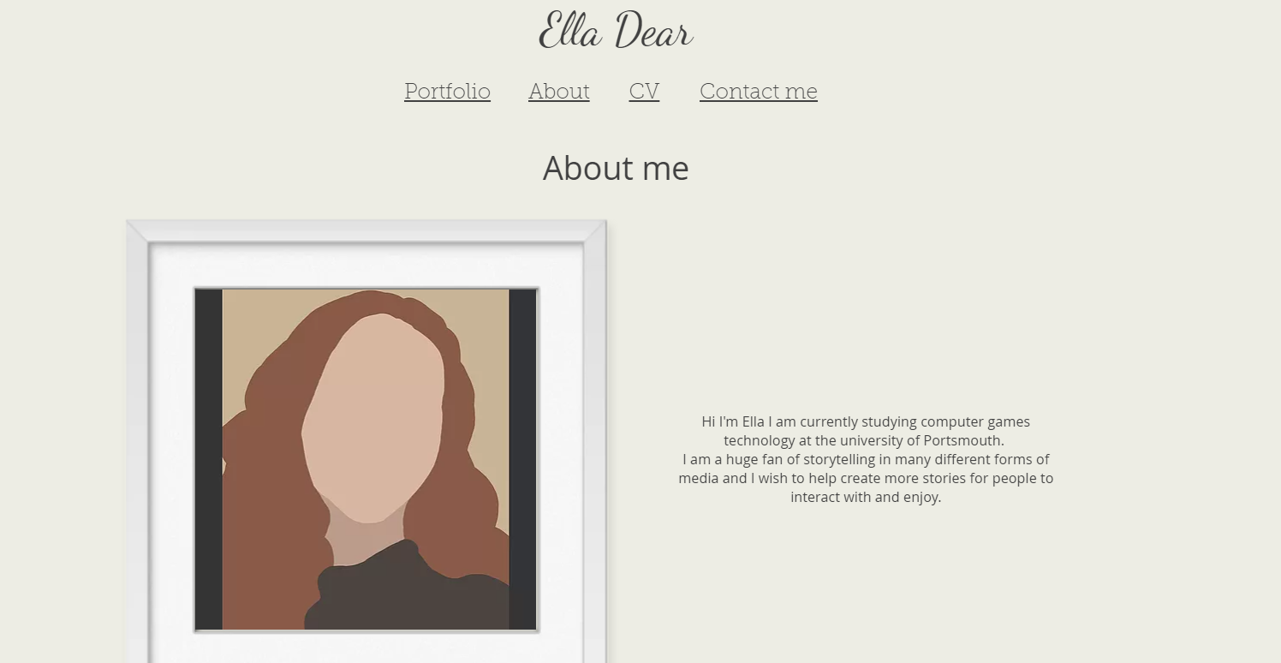

This page contains my current CV with some contact information:



This page contains a form which can be filled out to contact me and give me information that I can reply to.

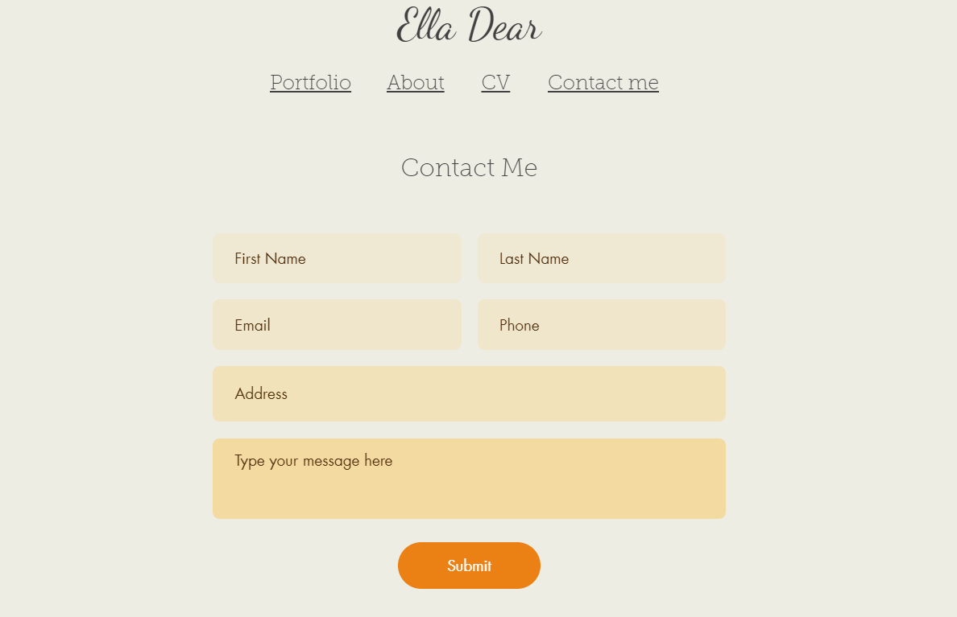

## TDEMO



# 04/11/2020

## TDEMO

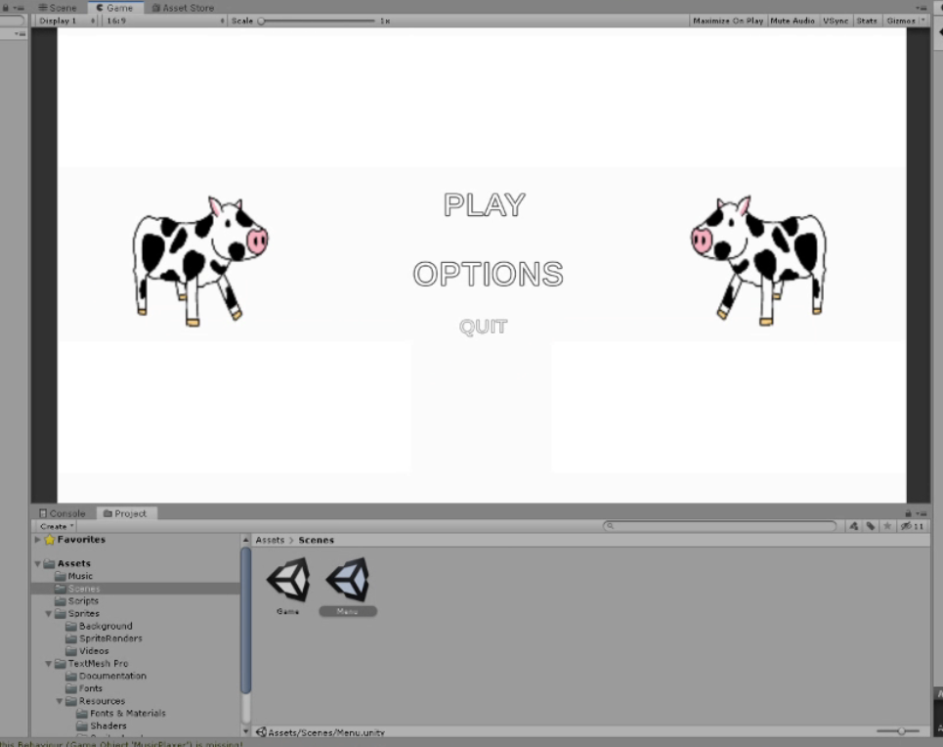

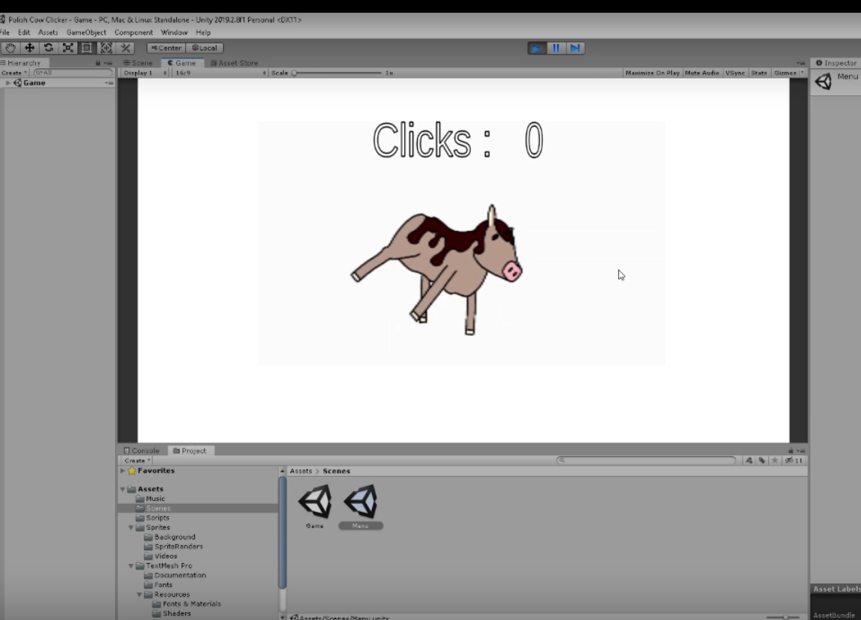

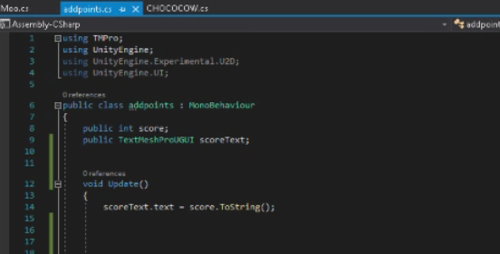

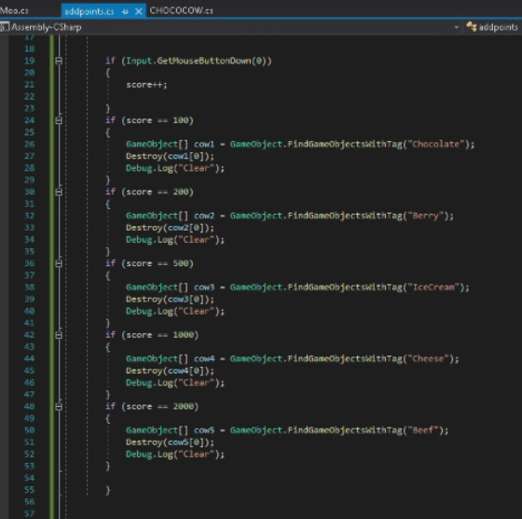

After my group had created the UI they found issues with the functionality of the game so I helped turn the addpoints class into more of a game manager and made the group aware of the FindGameObjectWithTag function which fixed the issues with calling the object to be deleted.

# 06/11/2020

## TDEMO

I got the majority of my group into a chat and have organised a time when we will discuss all the ideas and the roles everyone will play in the project.

# 07/11/2020

## TDEMO

I have arranged a meeting at 1 where my group will present and discuss ideas for our game. Joe has messaged me saying he may not be there for the meeting however he wishes to be a part of the art in the game so we will keep this in mind when assigning roles.

We set up a Trello account and group so we can add ideas and manage our work as a group.

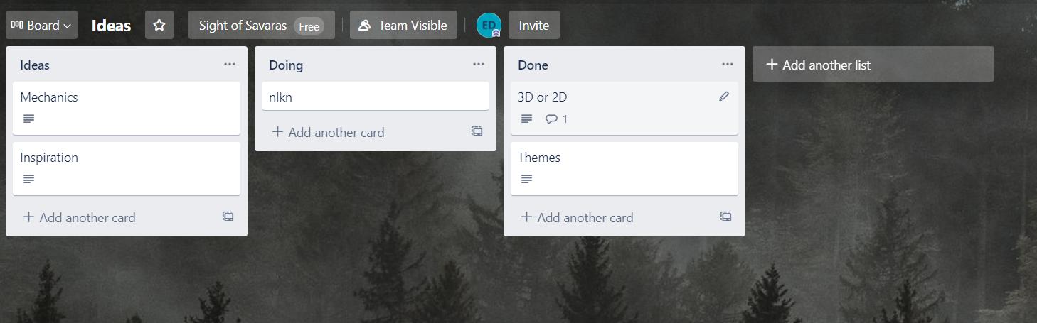

We used Trello to brainstorm ideas.

We decided to make a 3D game and first person. We narrowed down the theme to an island hopper where there were themed islands that the player must navigate and escape from. If we have time, we will create enemies for the player to fight to collect items.

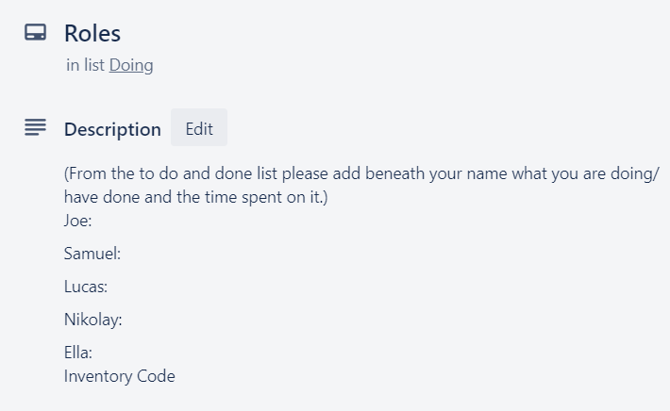

In a new board we wrote down the tasks that needed doing and I created the roles card where we would keep track of what everyone is doing and how long it took.

We used the unity collab feature to start working on the code for the project. Lucas

## Free Time

First attempt at dirt effect

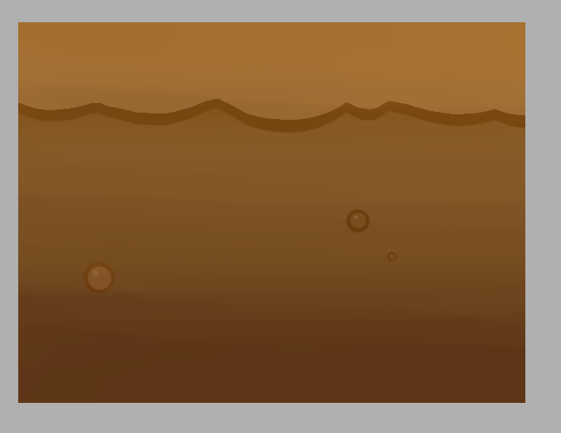

Then I spent a bit longer and using reference images

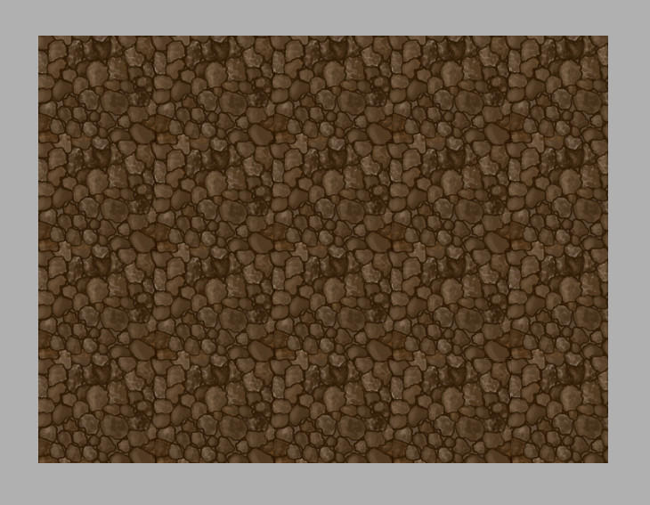

# 09/11/2020

## TDEMO

I created some quick sketches to get across what my interpretation of the ideas so far would look like.

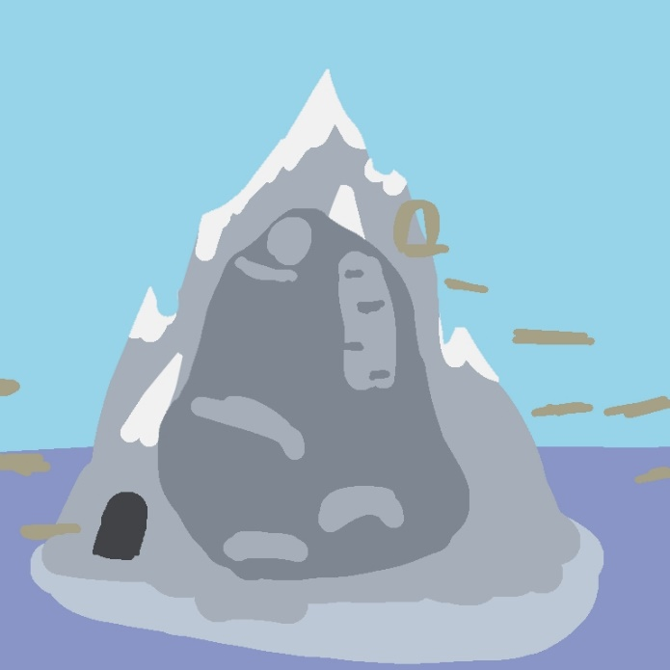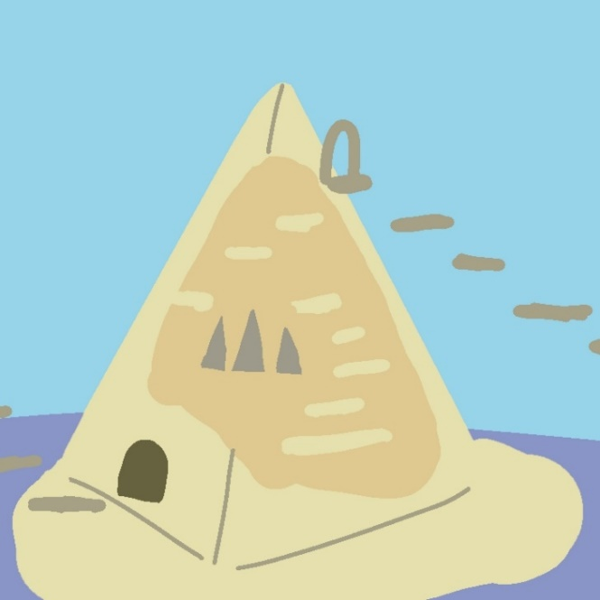

I created a menu screen using temporary art as a placeholder however if nothing else is drawn then it will be the final image

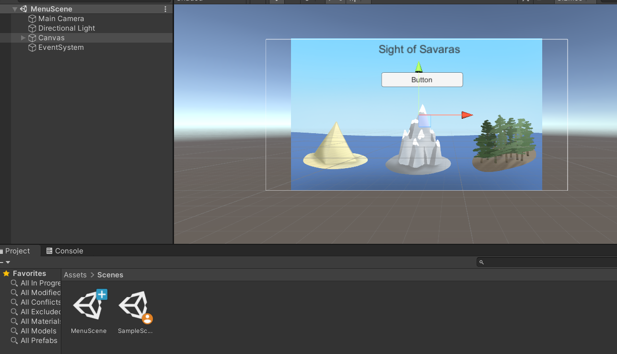

I then created this code to put onto a game object I named play which is attached to the play button and on click should change to the next scene.

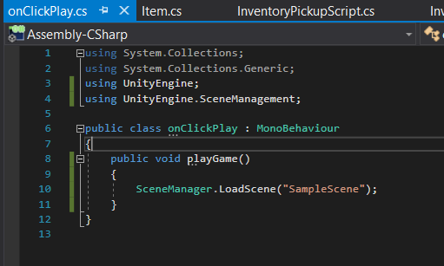

# 10/11/2020

## TDEMO

With help from Lucas I finished the menu screen with working play and quit buttons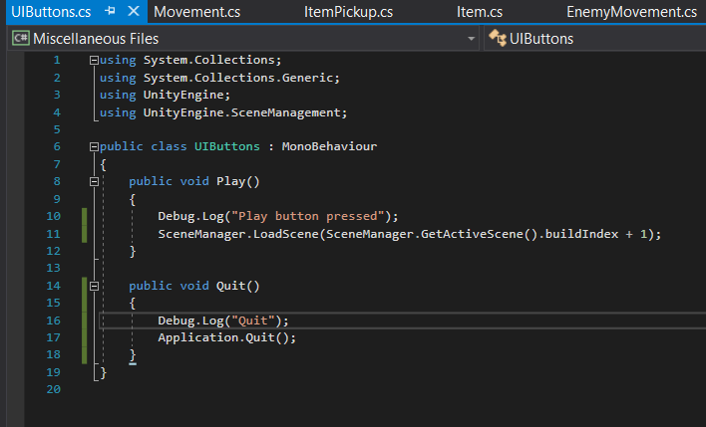

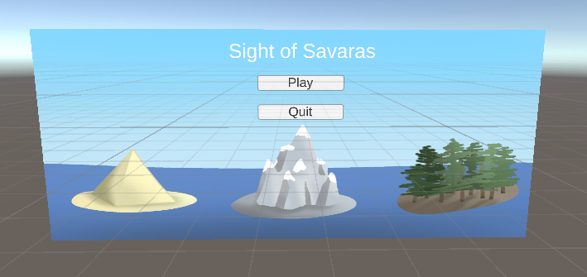

# 11/11/2020

## TDEMO

Stefan joined our group and was added to the group chat.

# 16/11/2020

## TDEMO

I created assets for the inventory icons these took about 3 hours

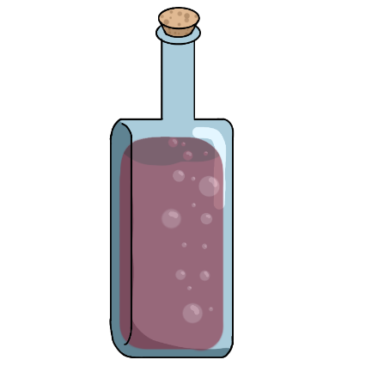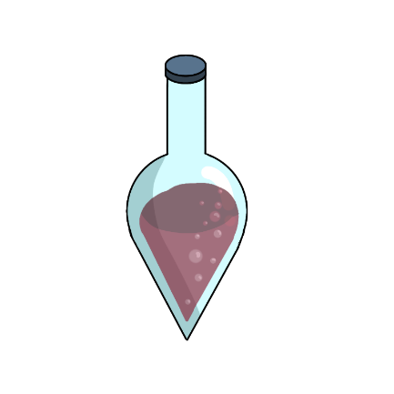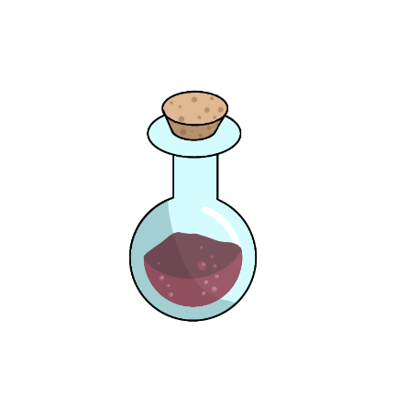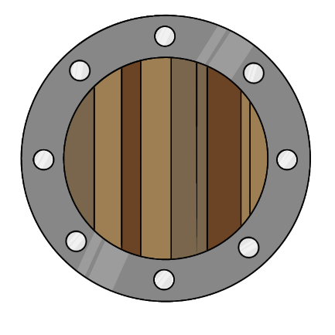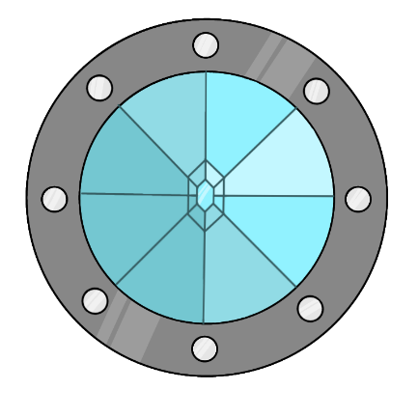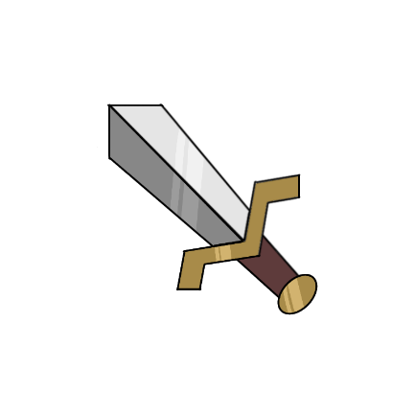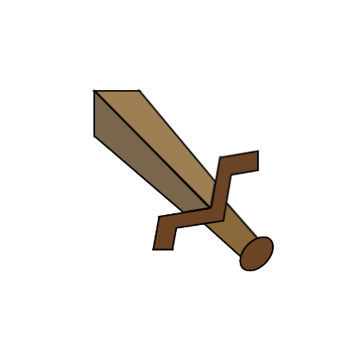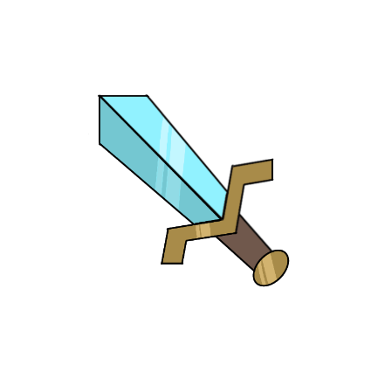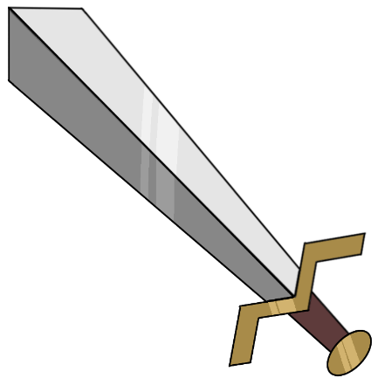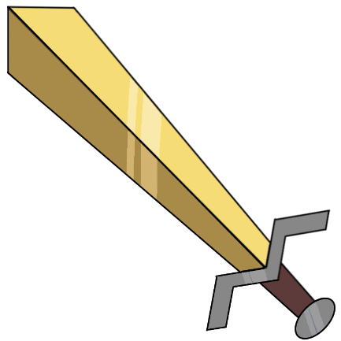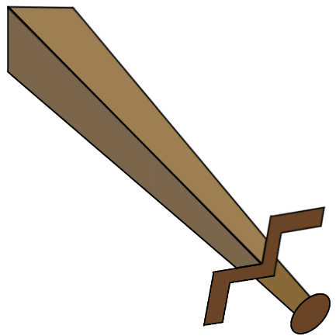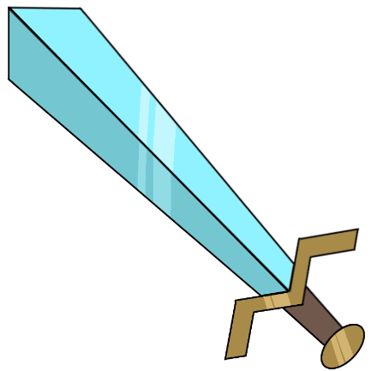

Samuel sent in the 3d models of the swords and daggers.

# 17/11/2020

## TDEMO

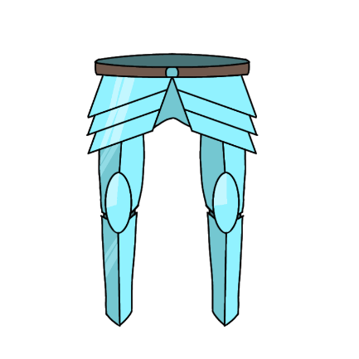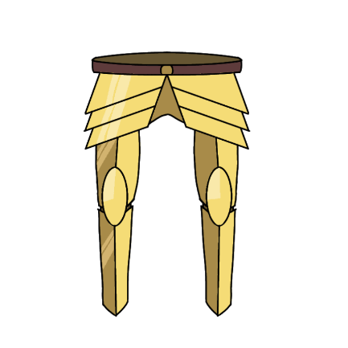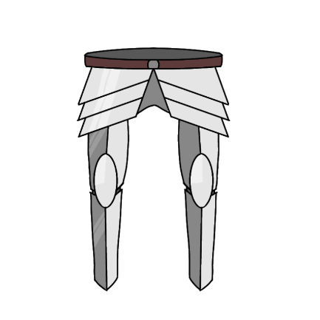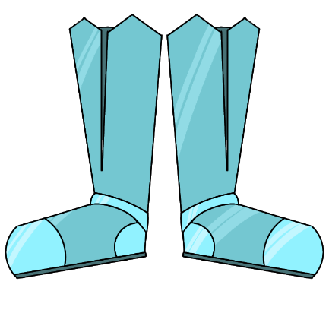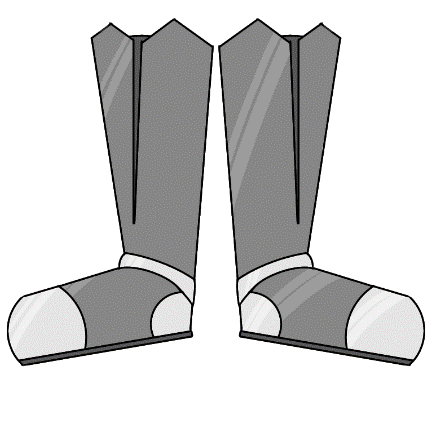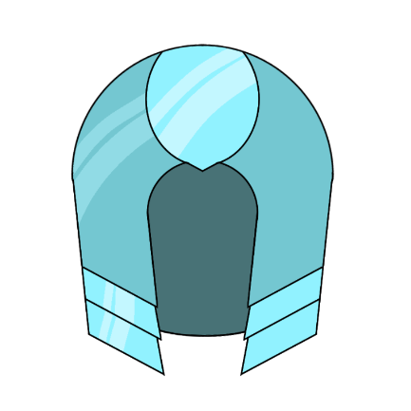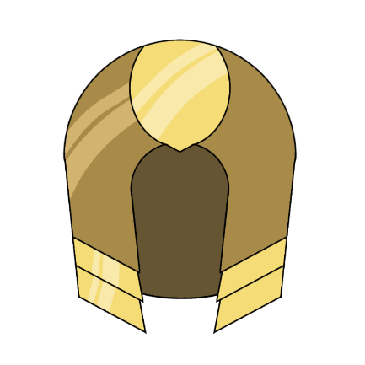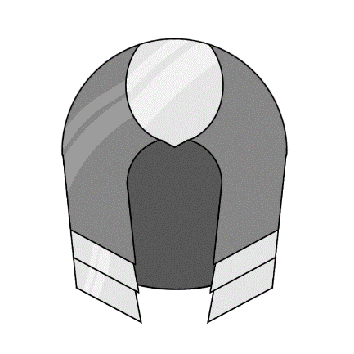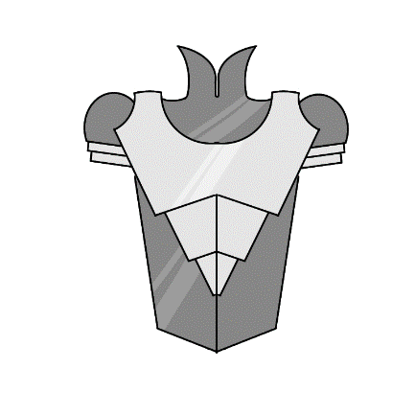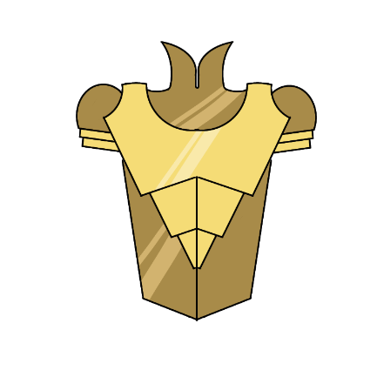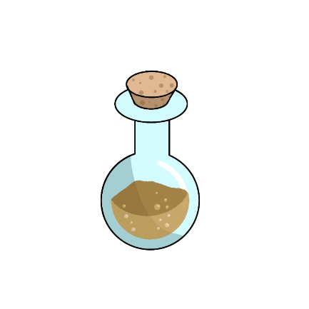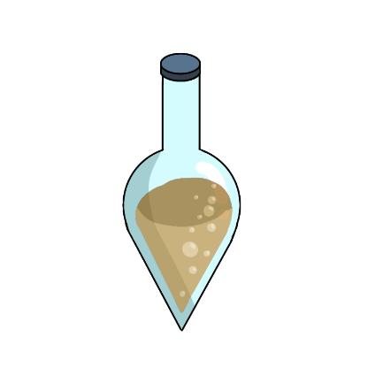

# 18/11/2020

## TDEMO

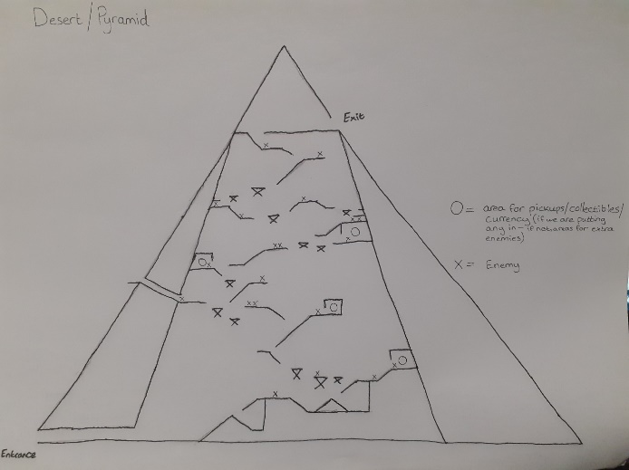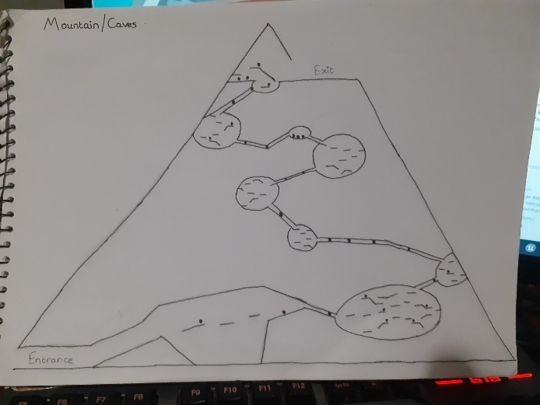

Using these plans drawn by joe I started to create the levels in 3D in unity.

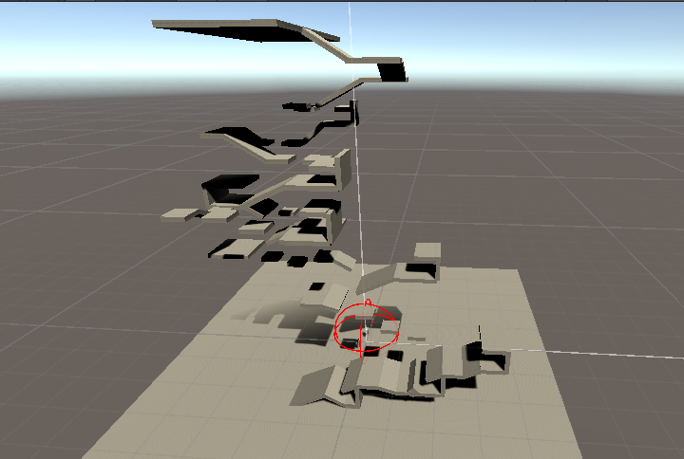

The first one took 1 hour and uses 67 cube objects.

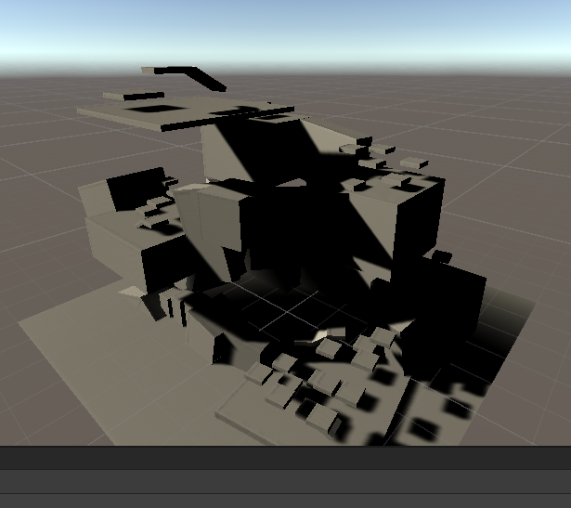

I spent another hour creating the platforms for the cave level.

the loot drop wont be difficult. put everything in a list and select a random one and then spawn it

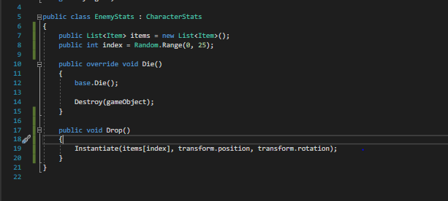

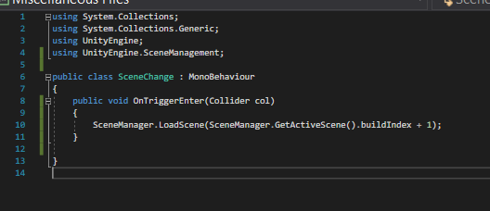

# 21/11/2020

## TDEMO

Feedback on the game

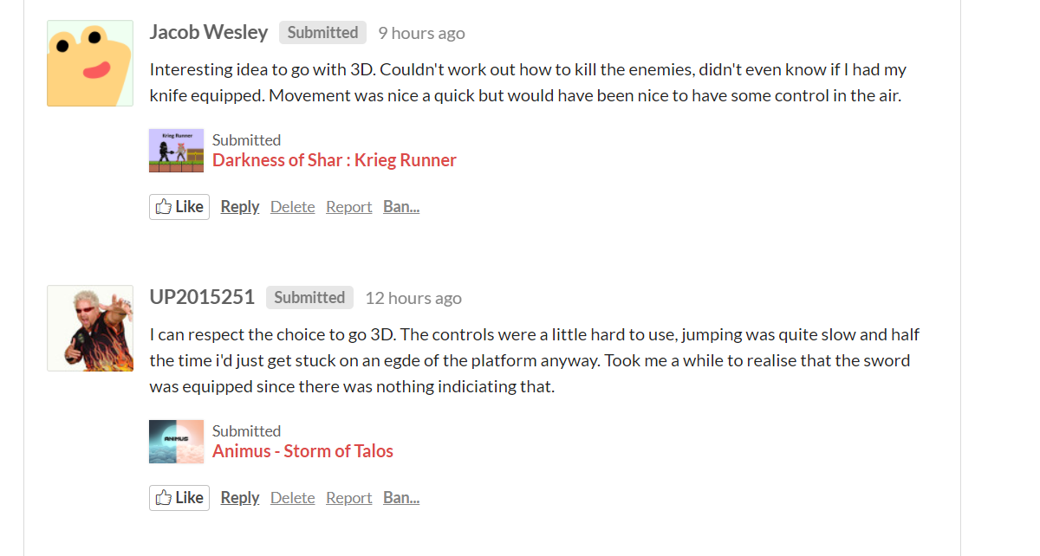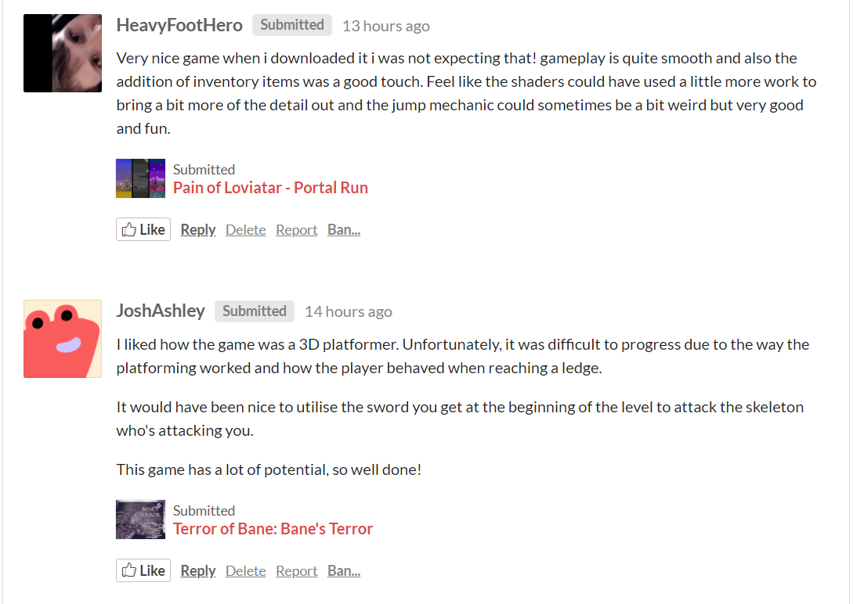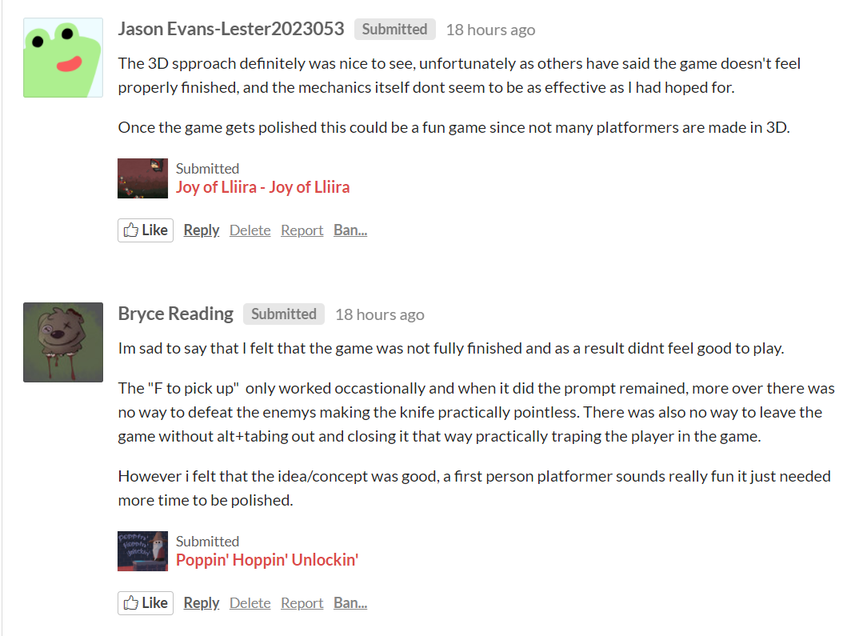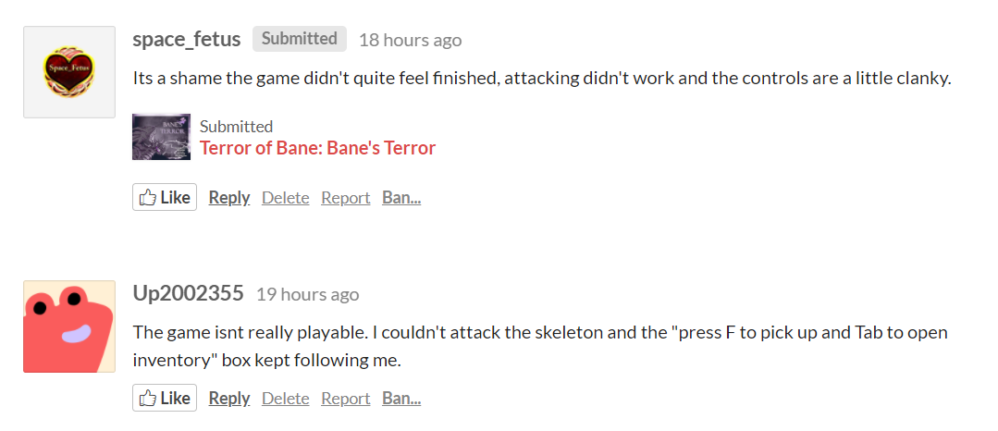

I started to create a 3D model for my next group project

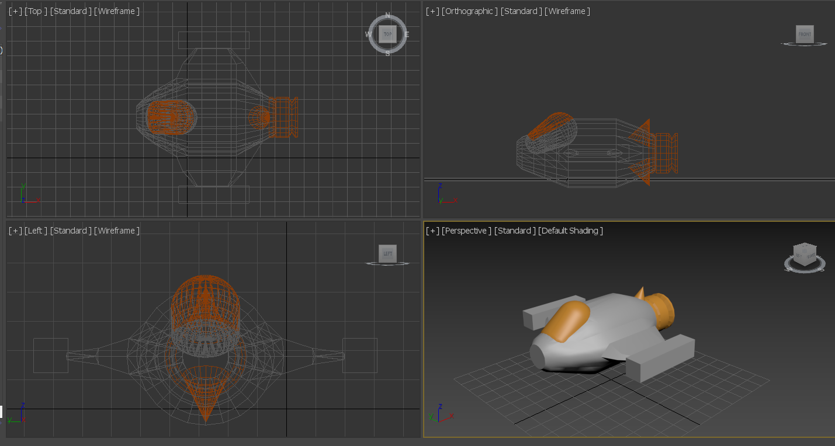

Based on discussion we got rid of the spikes

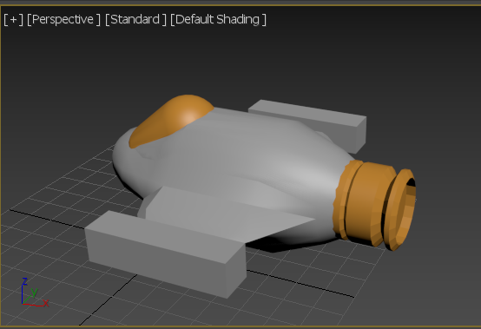

# 23/11/2020

## TDEMO

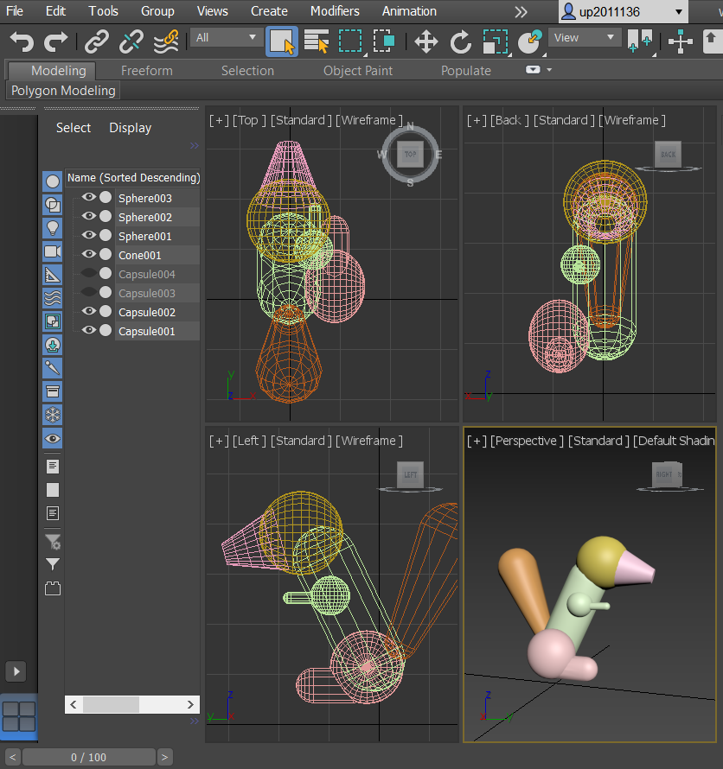

# 25/11/2020

## TDEMO

Using youtube tutorials I wrote some code which should cause the enemy to follow the player when it gets close this is temporary as this isn’t exactly how we want the enemies to act so I will wait for the other programmer to add to the player code so I may change mine accordingly.

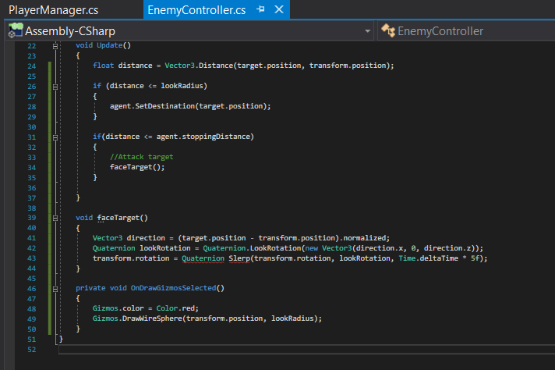

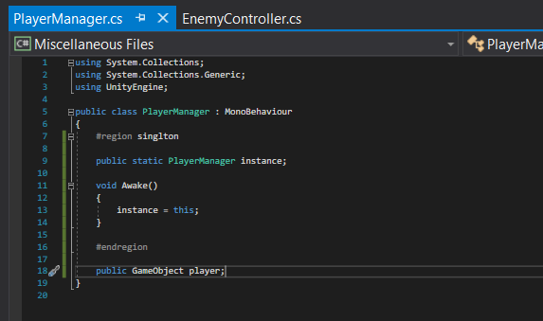

# 26/11/2020

## TDEMO

I worked on re-doing the ship to make it easier to texture and was successful so I will add texture tomorrow.

I have learnt that when something isn’t working and there is a possibility of starting again I should stop working on it and see if starting again is a better option and isn’t more time consuming.

# 27/11/2020

## TDEMO

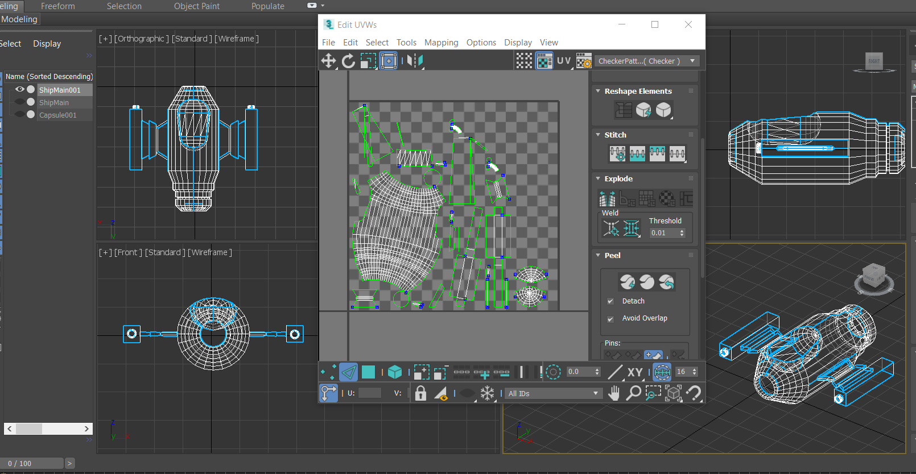

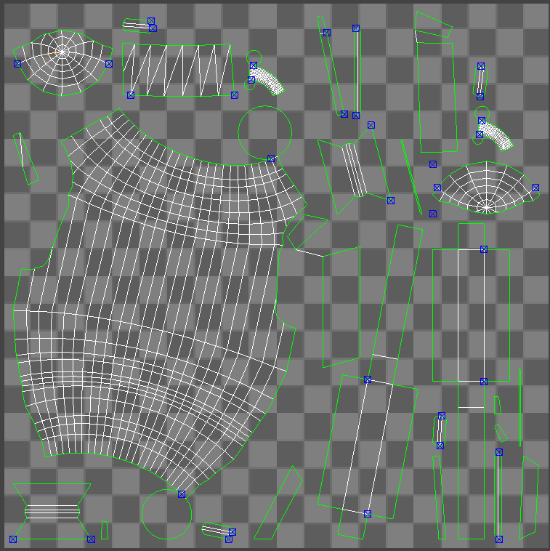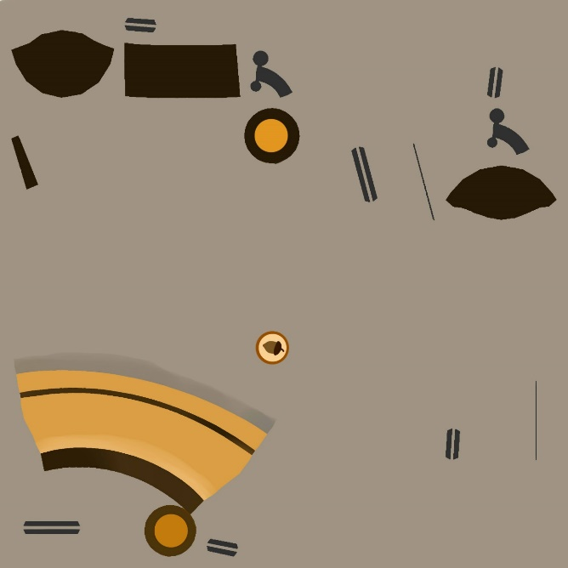

I created texture for the space ship and attempted to add the texture to the model following this tutorial <https://www.youtube.com/watch?v=cl7LLJmp9Ng&t=716s>

However when attempting to create the material I was unable to find the scanline standard as the scanline section was replaced with the Arnold section I also attempted to search for a standard material however I couldn’t find anything with the same basic parameters as in the video.

# 28/11/2020

## TDEMO

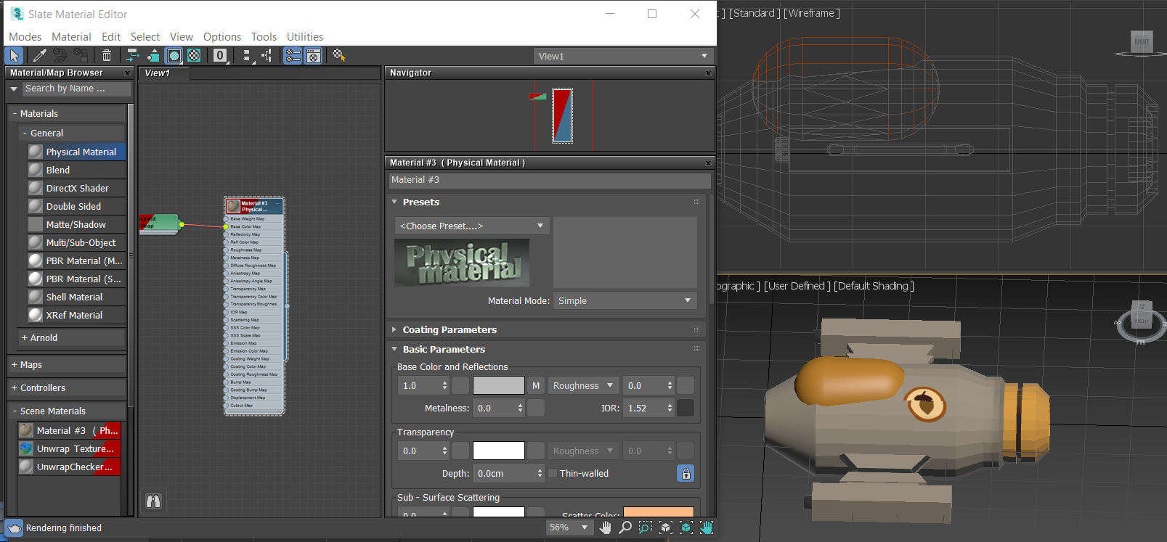

I used a physical material to add the skin however it looked weird so I had to edit it a bit

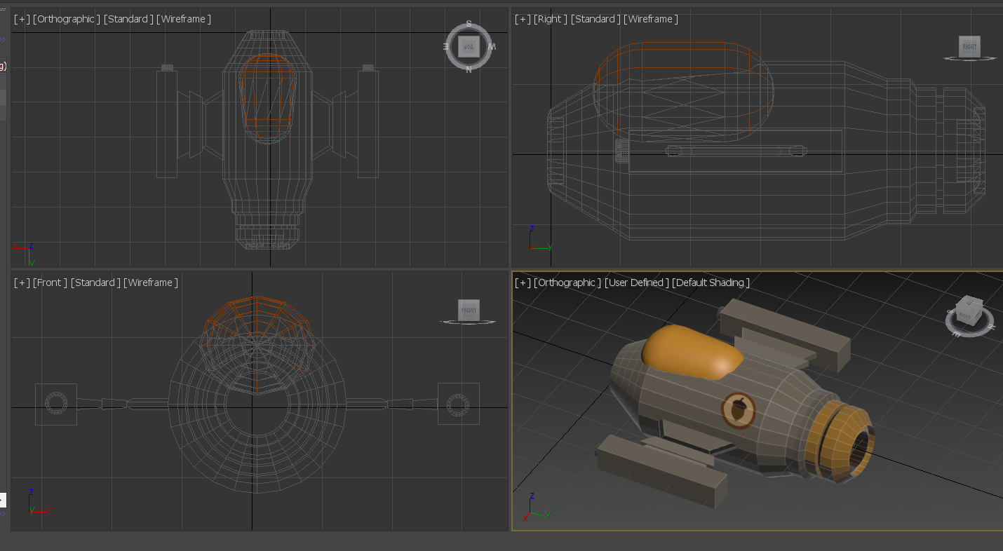

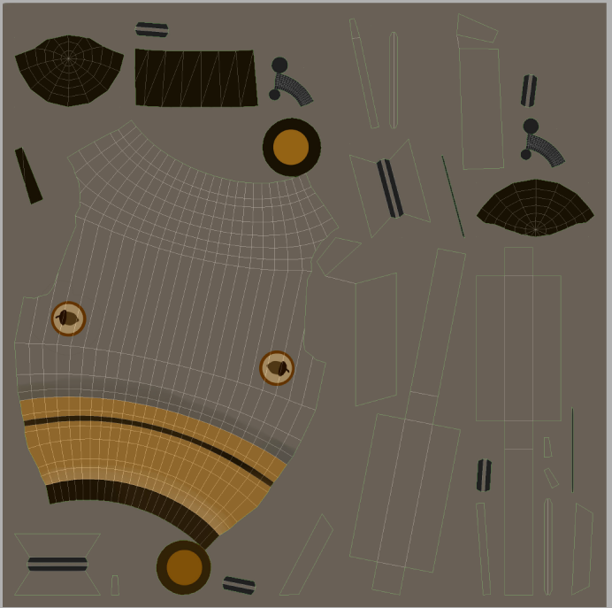

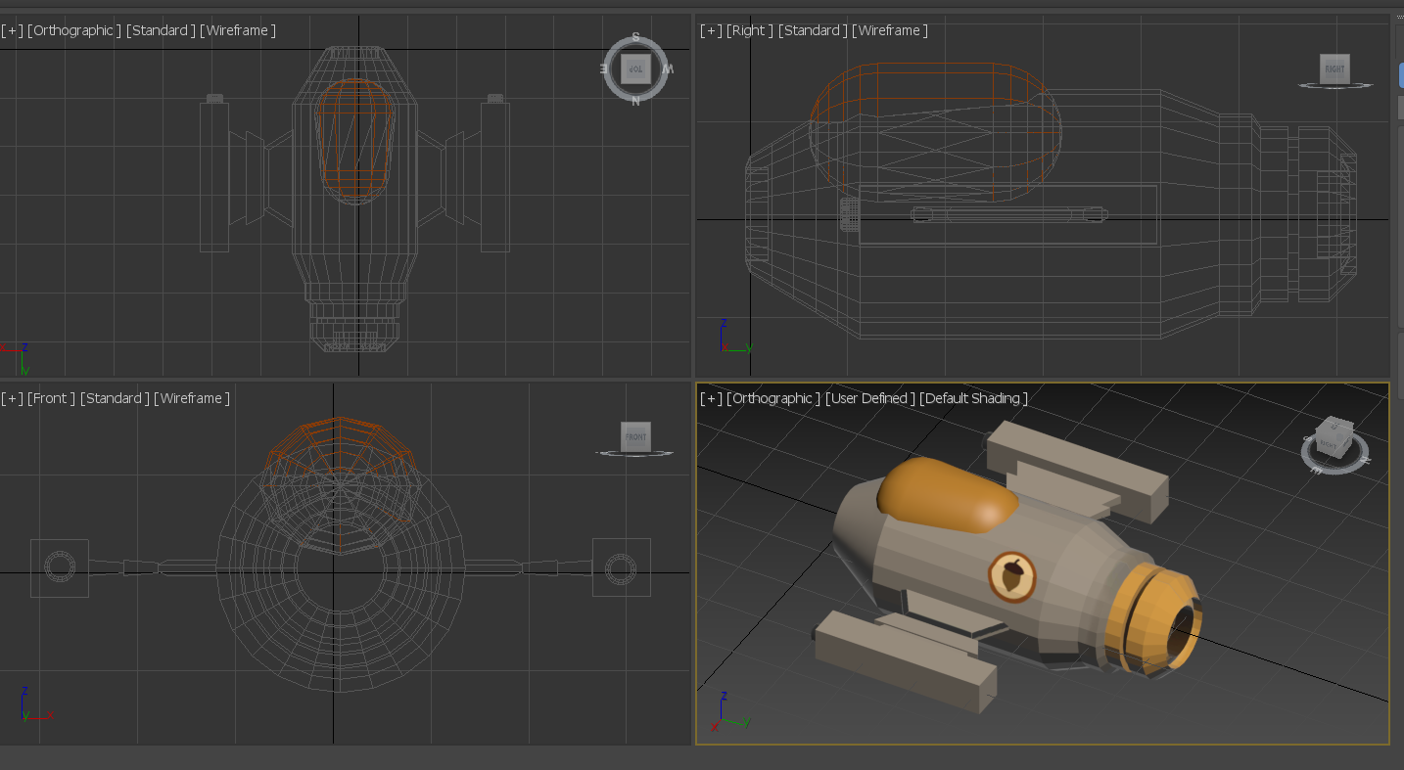

Next using the concept art provided

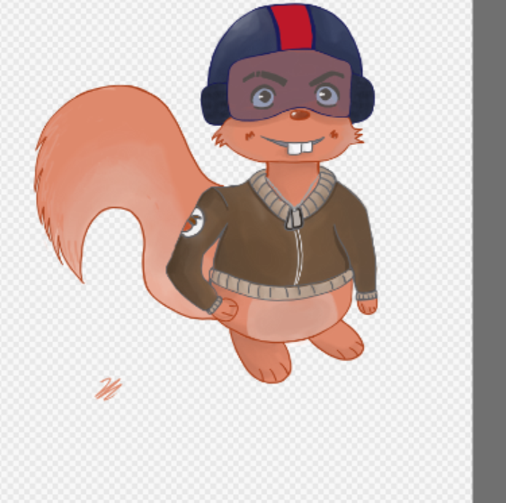 I drew up a reference 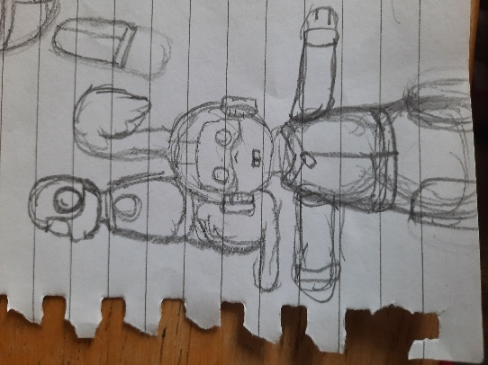

and started to improve the squirrel model

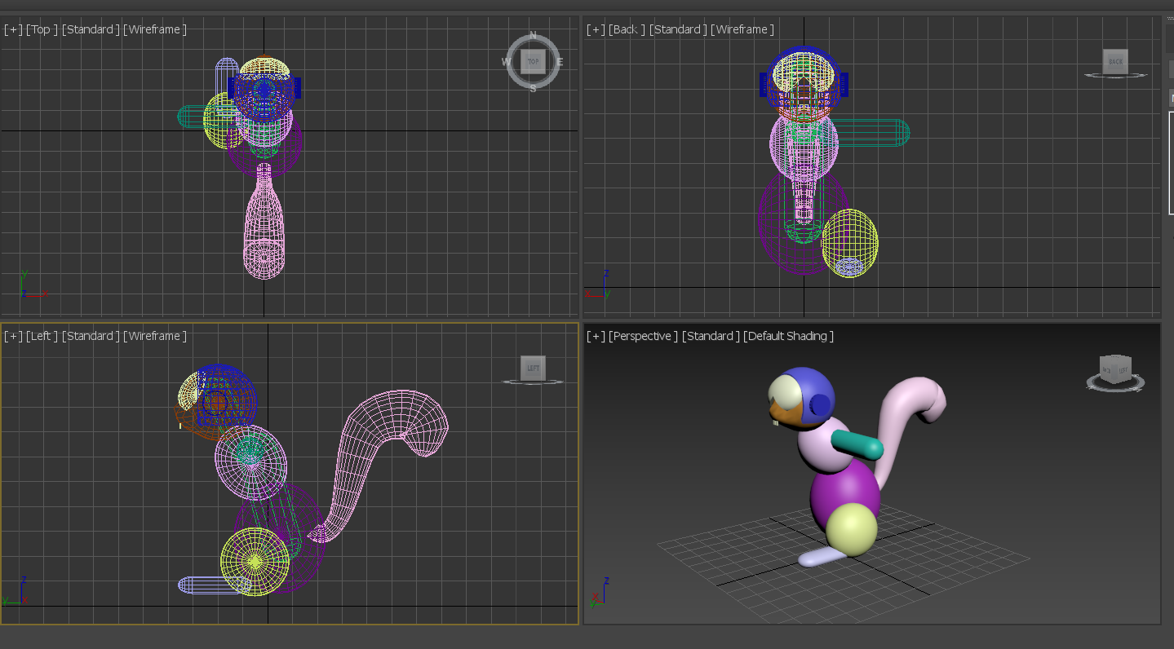

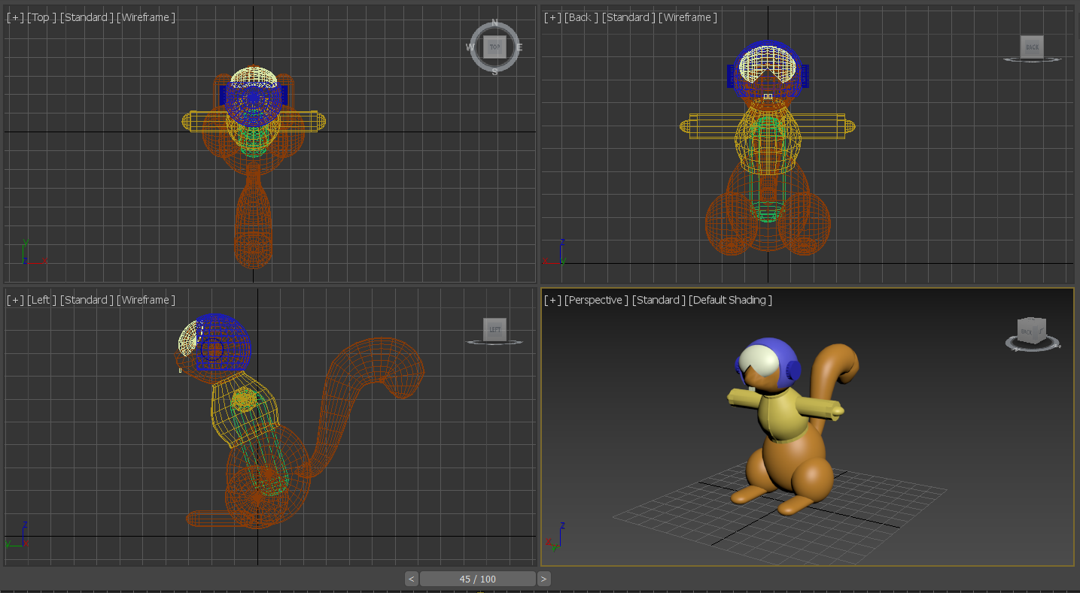

# 29/11/2020

## TDEMO

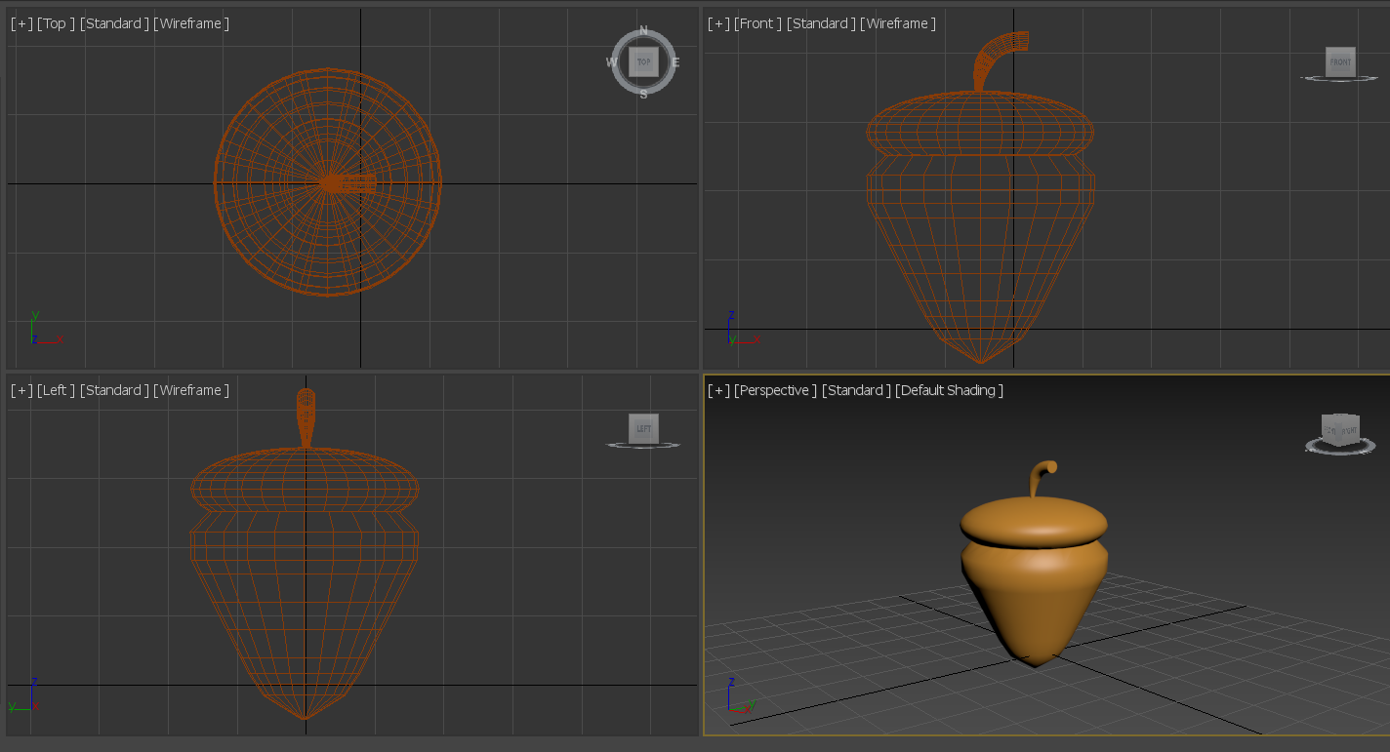

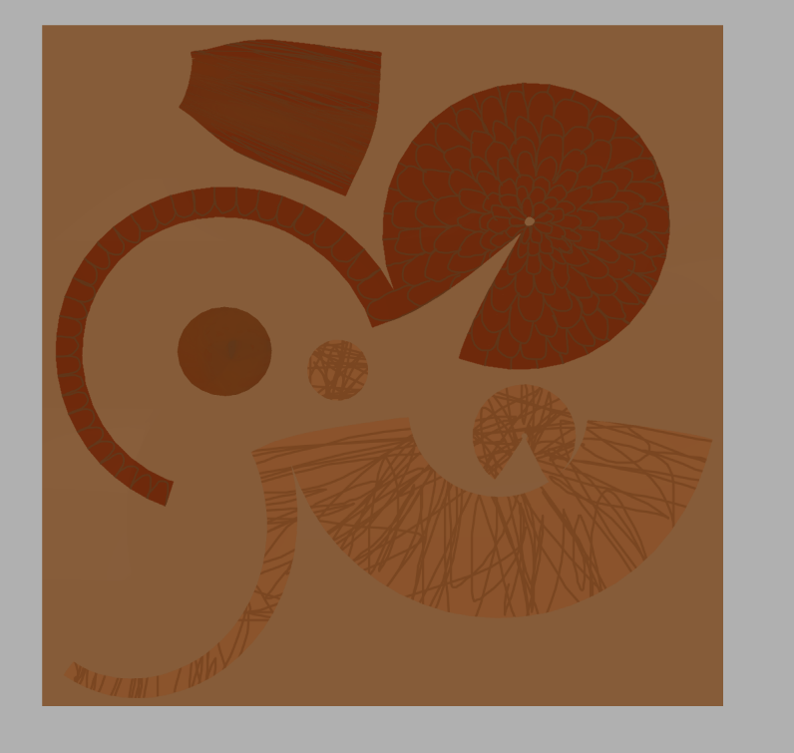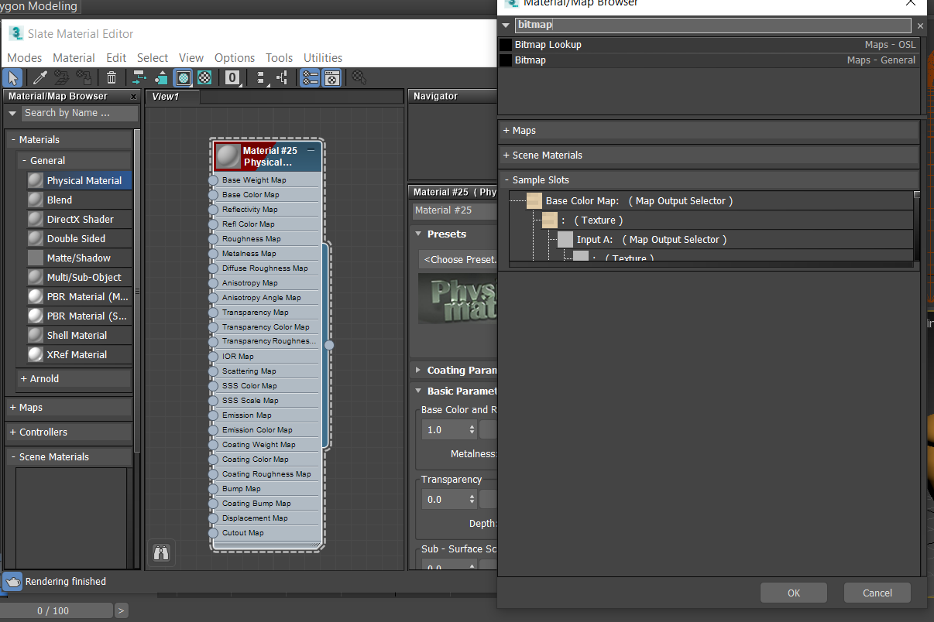

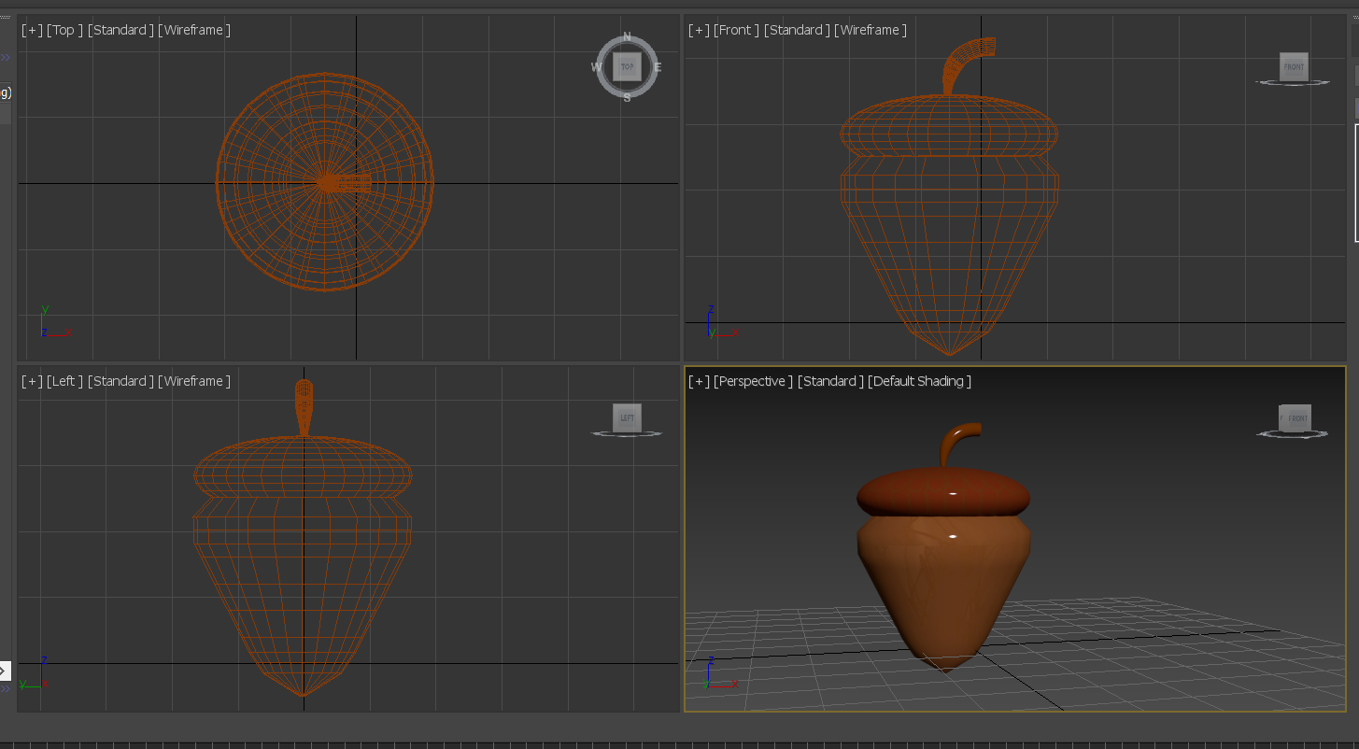

# 01/12/2020

## TDEMO

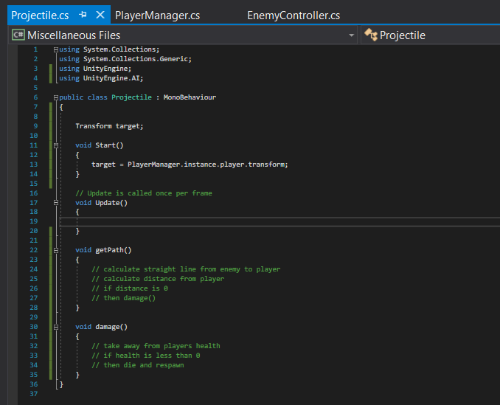

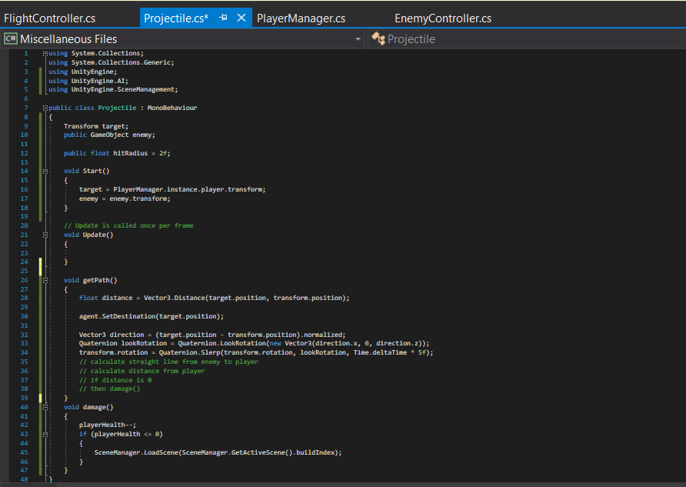

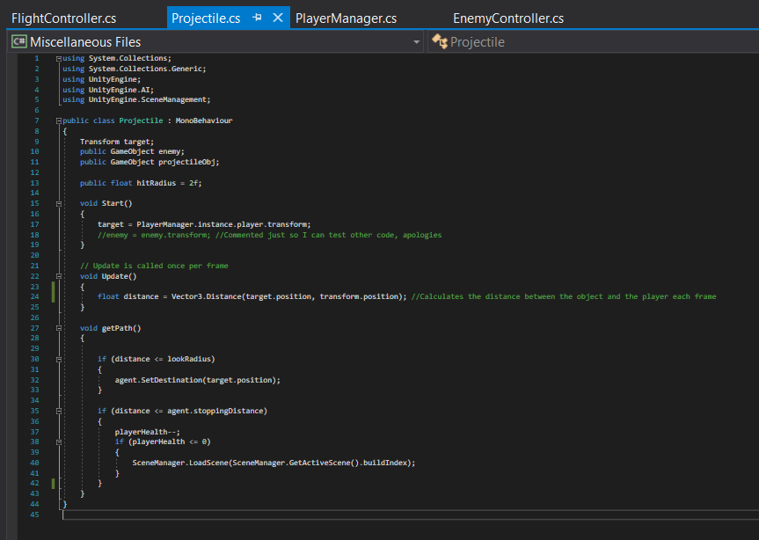

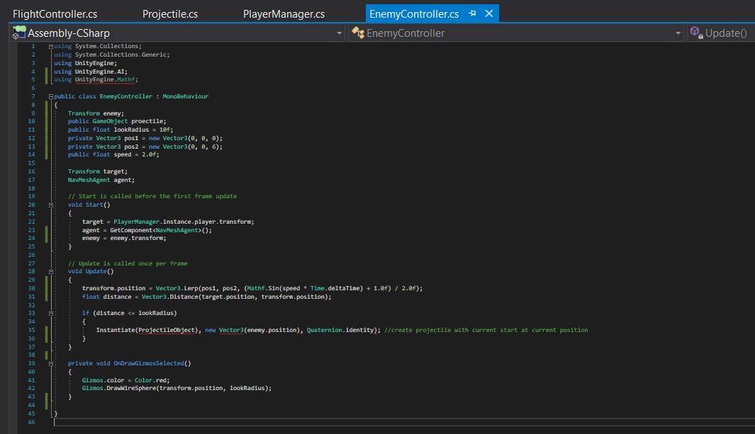

I went through and fixed any minor errors.

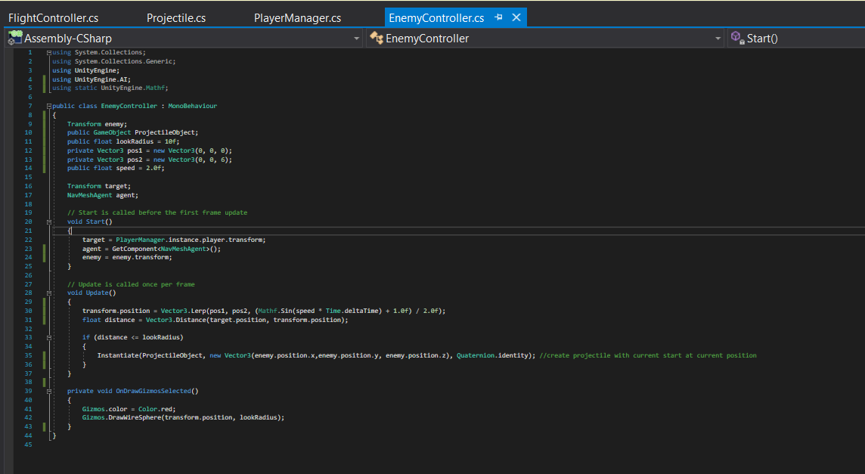

I added this to make the enemy wait between attacking

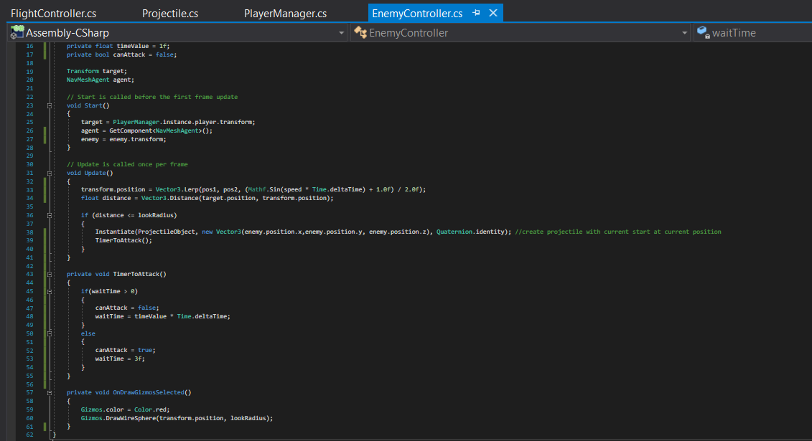

# 02/12/2020

## TDEMO

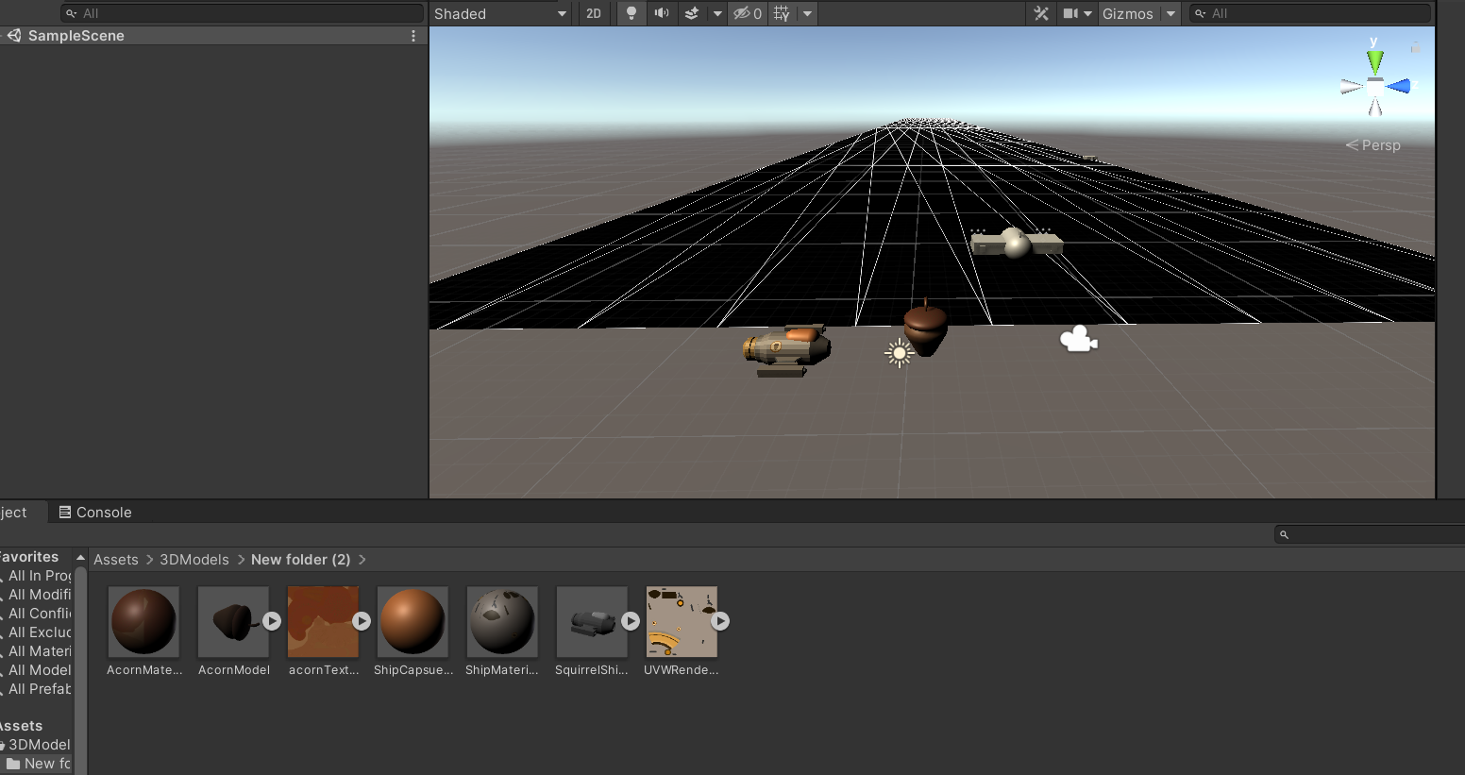

I went through separate assets and code I created and added them to the project or made sure there wernt errors.

# 03/12/2020

## TDEMO

I spent the morning assigning the correct code and components to the enemy models

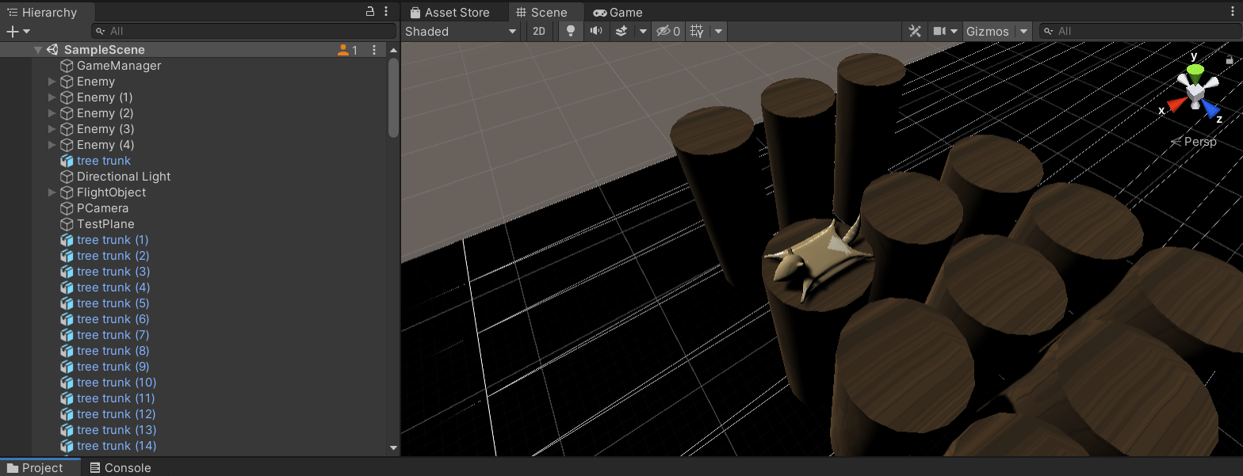

The game was submitted to the game jam

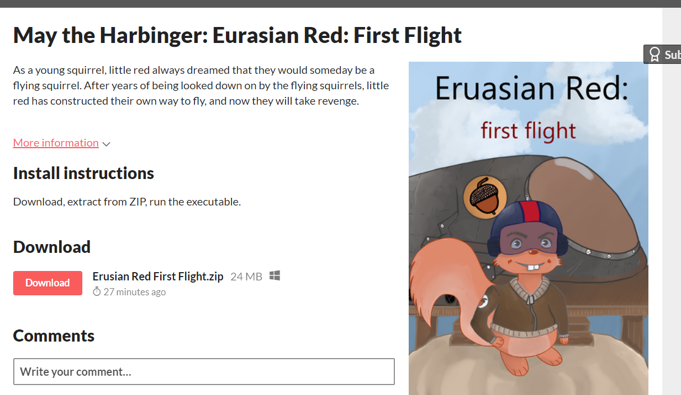

# 04/12/2020

## TDEMO

### Feedback:

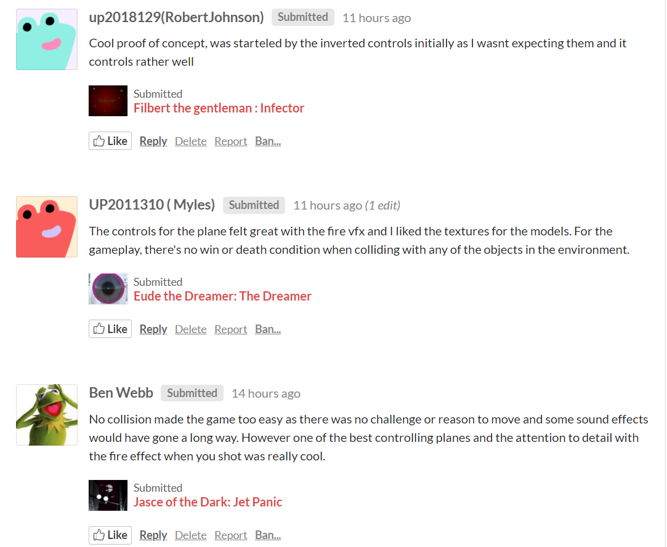

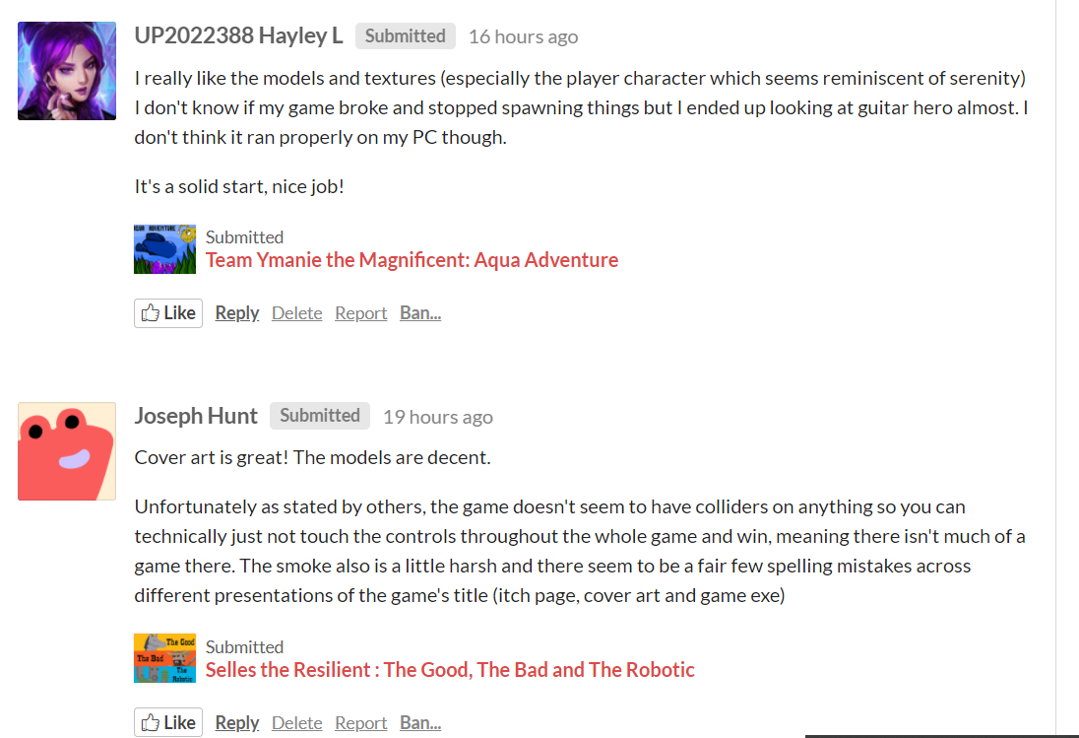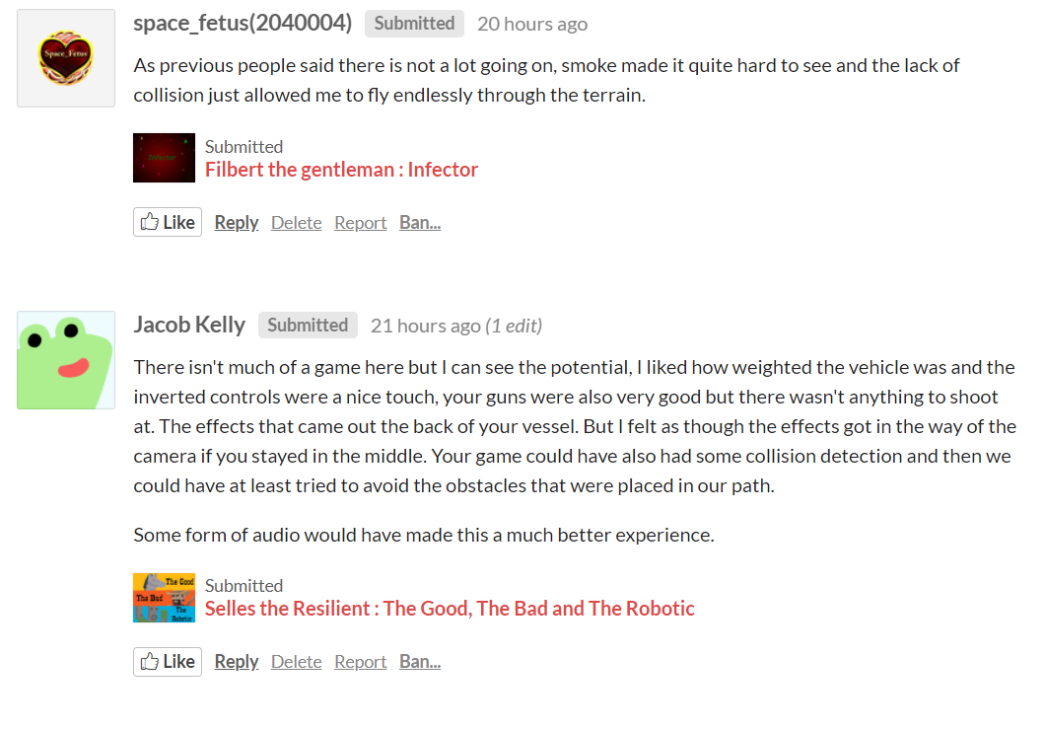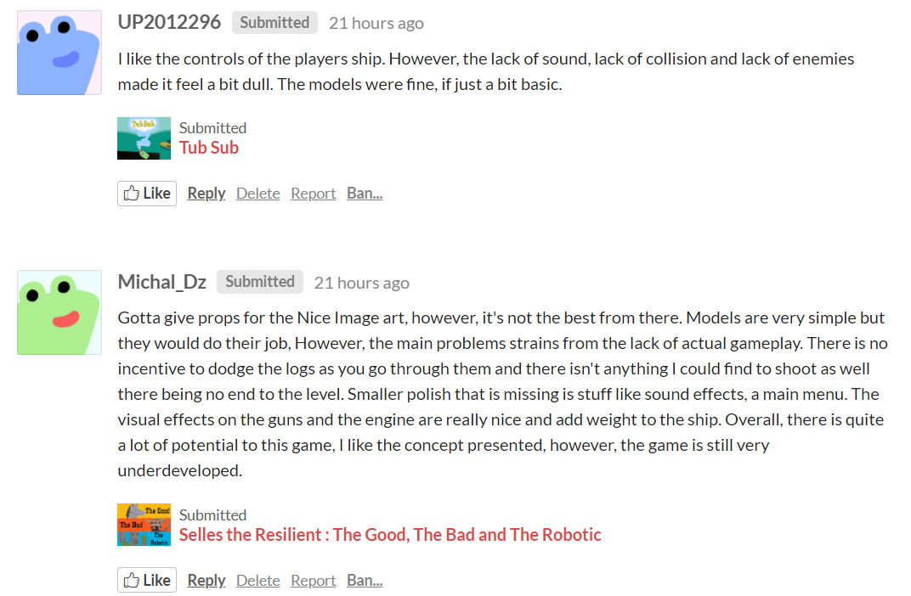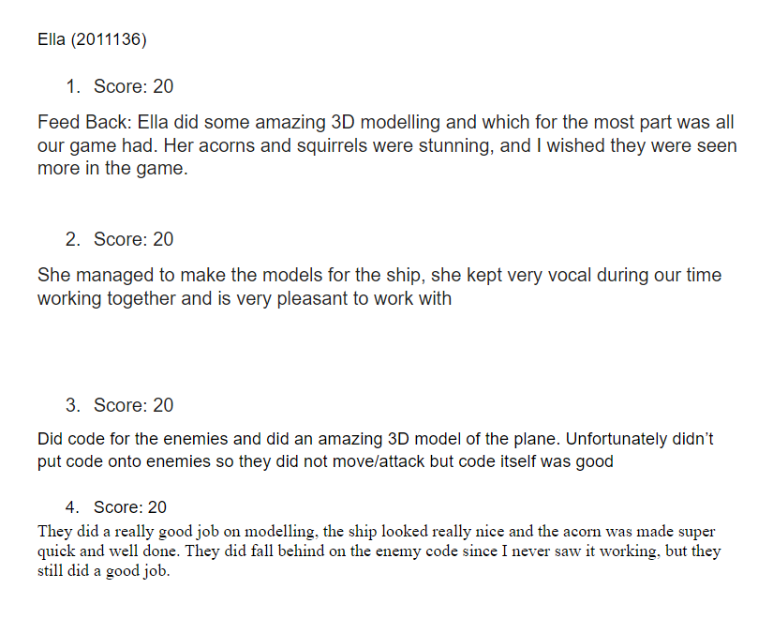

# 10/12/2020

## TDEMO

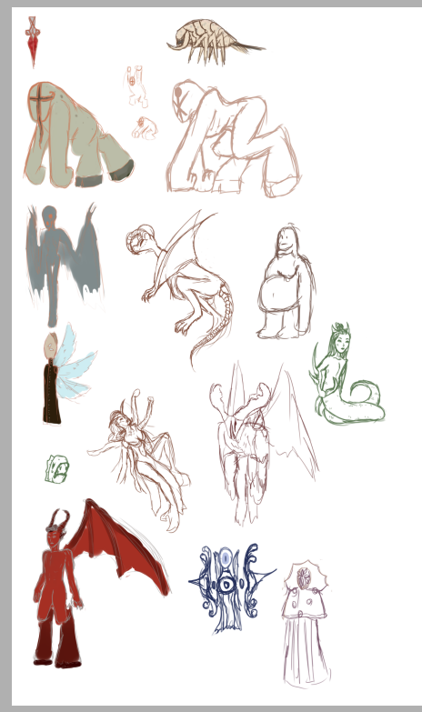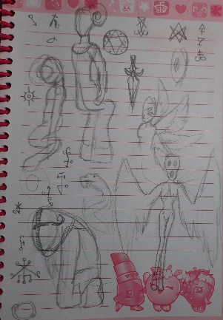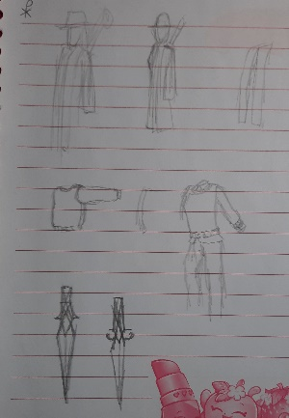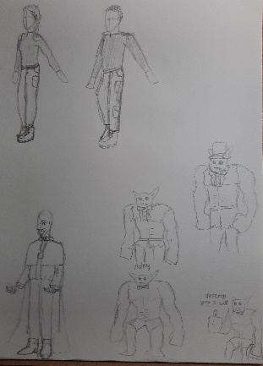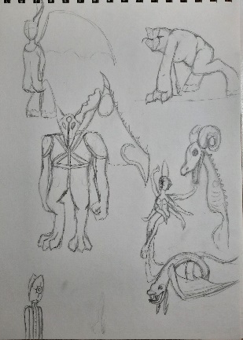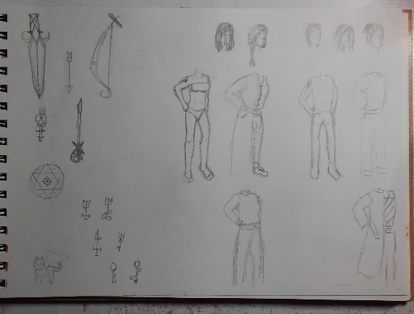

# 12/12/2020

## TDEMO

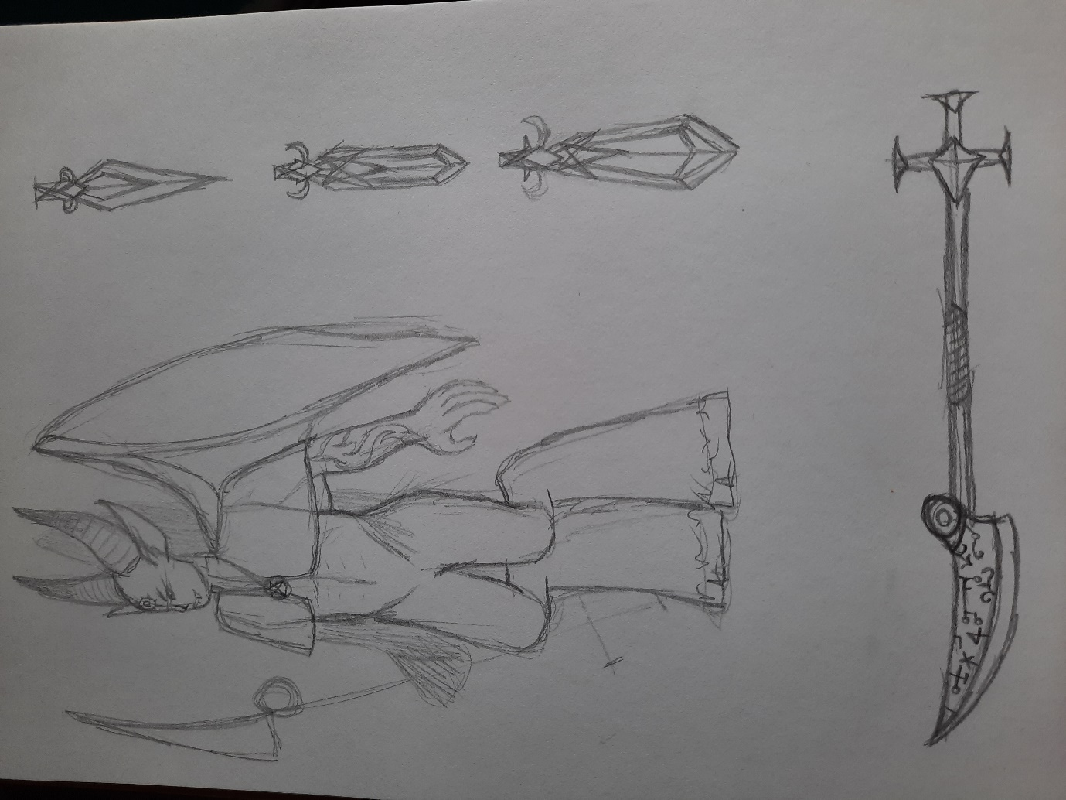

# 13/12/2020

## TDEMO

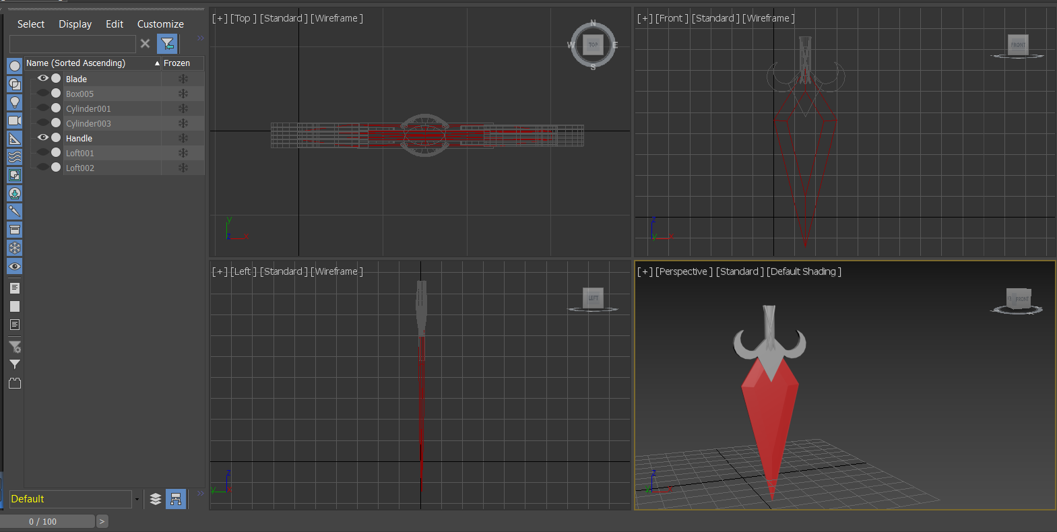

# 14/12/2020

## TDEMO

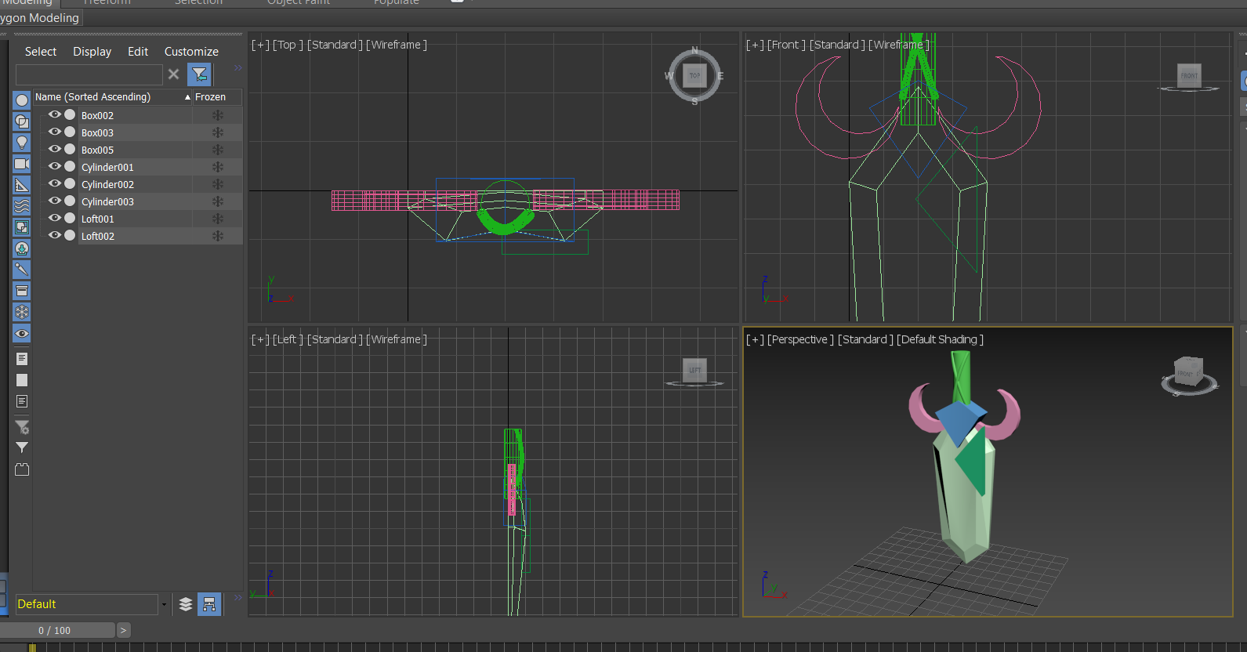

# 15/12/2020

## TDEMO

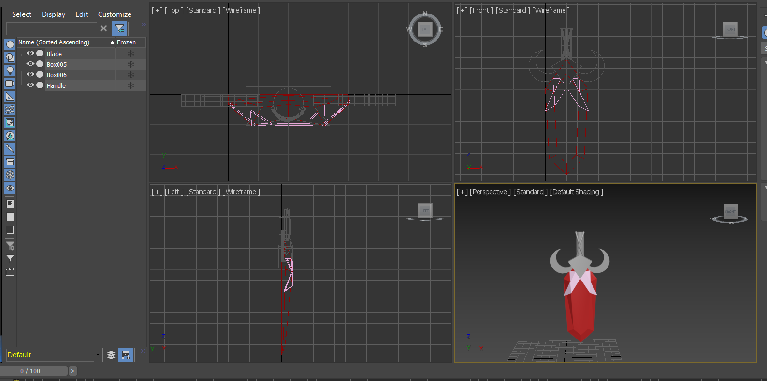

# 16/12/2020

## TDEMO

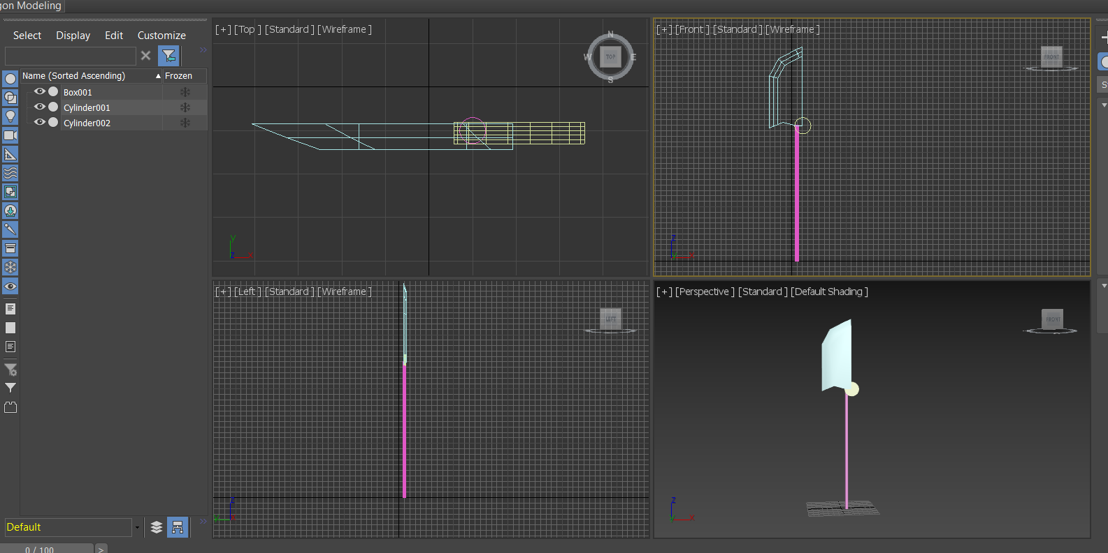

# 17/12/2020

## TDEMO

